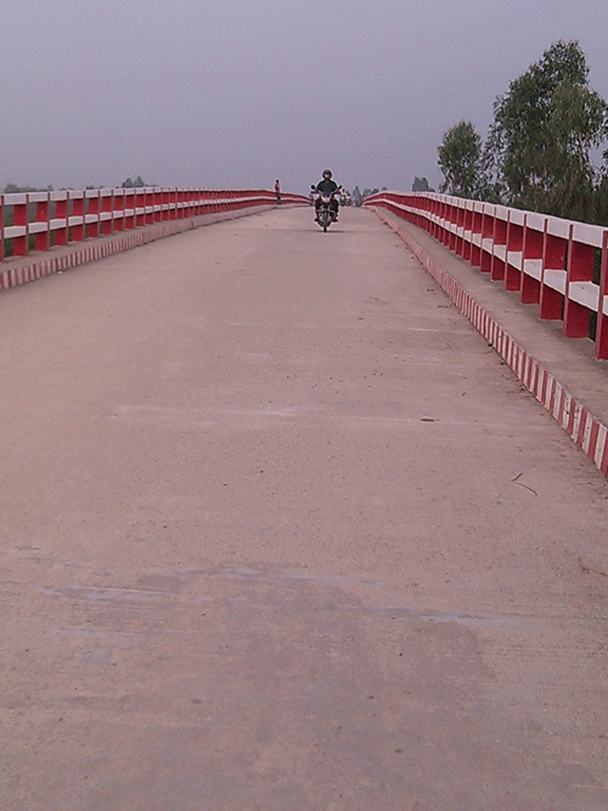

400.225 m.Long PC Girder Bridge on Amaitara- Agradigon Road over Atrai River at ch.9.25km DHAMOIRHAT completed under PMP

