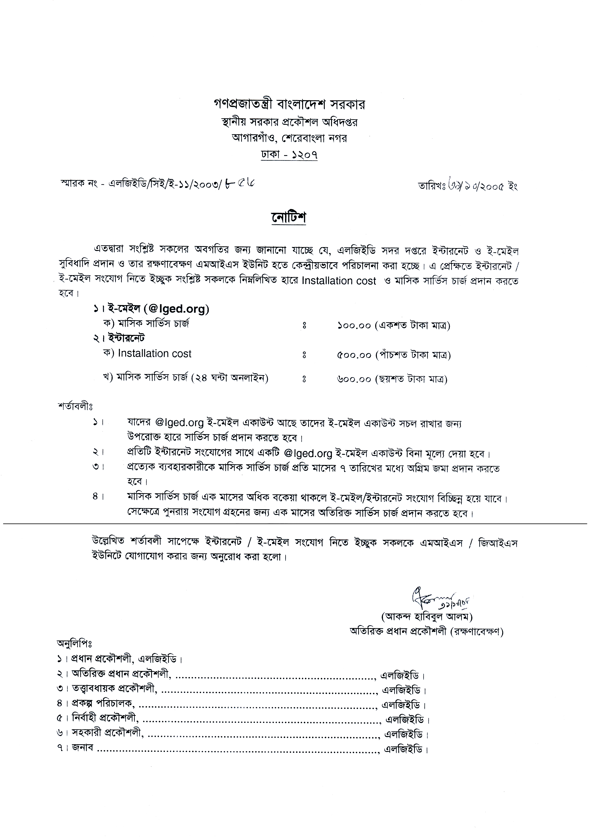

Internet / E-Mail Connection
Registration Form

User Code :

Connection Type : Internet E-Mail Both

Name :

Designation :
Office/Project :

LGED RDEC Level

Telephone / Mobile: Intercom:

Computer Name :

MAC Address :
 |  | - |  |  | - |  |  | - |  |  | - |  |  | -

Installation Cost :
Tk. | 5 | 0 | 0
(For Internet)

Monthly Service Charge:
Tk. | 6 | 0 | 0 | One e-mail account @lged.org free with each Internet Connection
(For Internet)

Monthly Service Charge:
Tk. | 1 | 0 | 0 | For e-mail account @lged.org
(For E-Mail)

Proposed / Existing:
 |  |  |  |  |  |  |  |  |  |  |  |  |  |  |  | @ | l | g | e | d | . | o | r | g
Email Account Password
Leased IP Address:
172 . 1 . .

I have deposited Tk…………. (………………………………………only) for Installation charge.

D D M M Y Y Y Y
Date of Application:
 |  | / |  |  | / | 2 | 0

Signature of the Applicant: Recommended By: Signature of the Unit In Charge:

