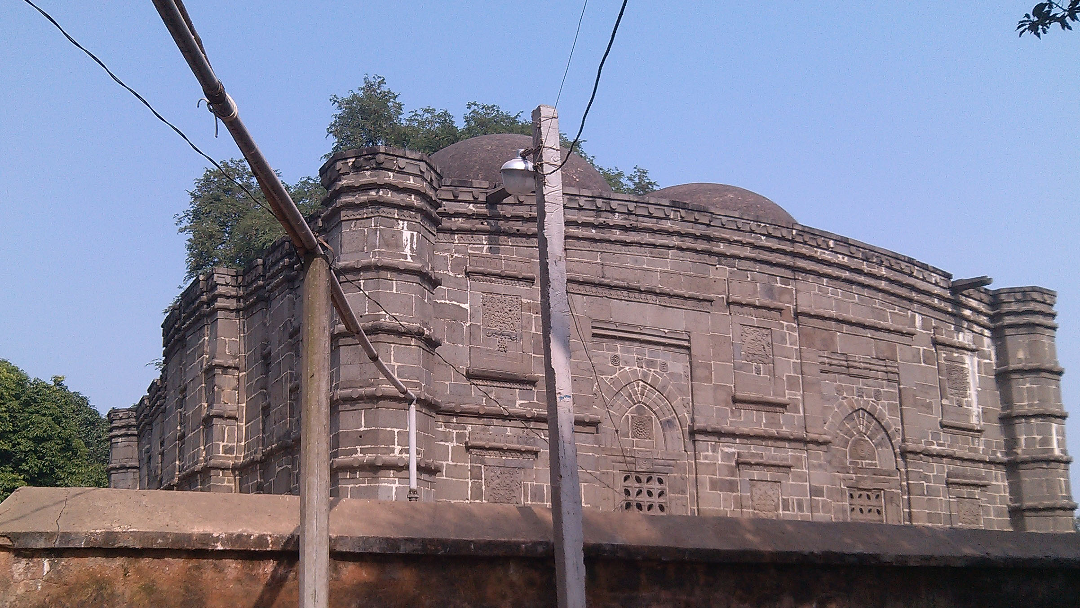

Kusumba Mosque at Manda, Naogaon

