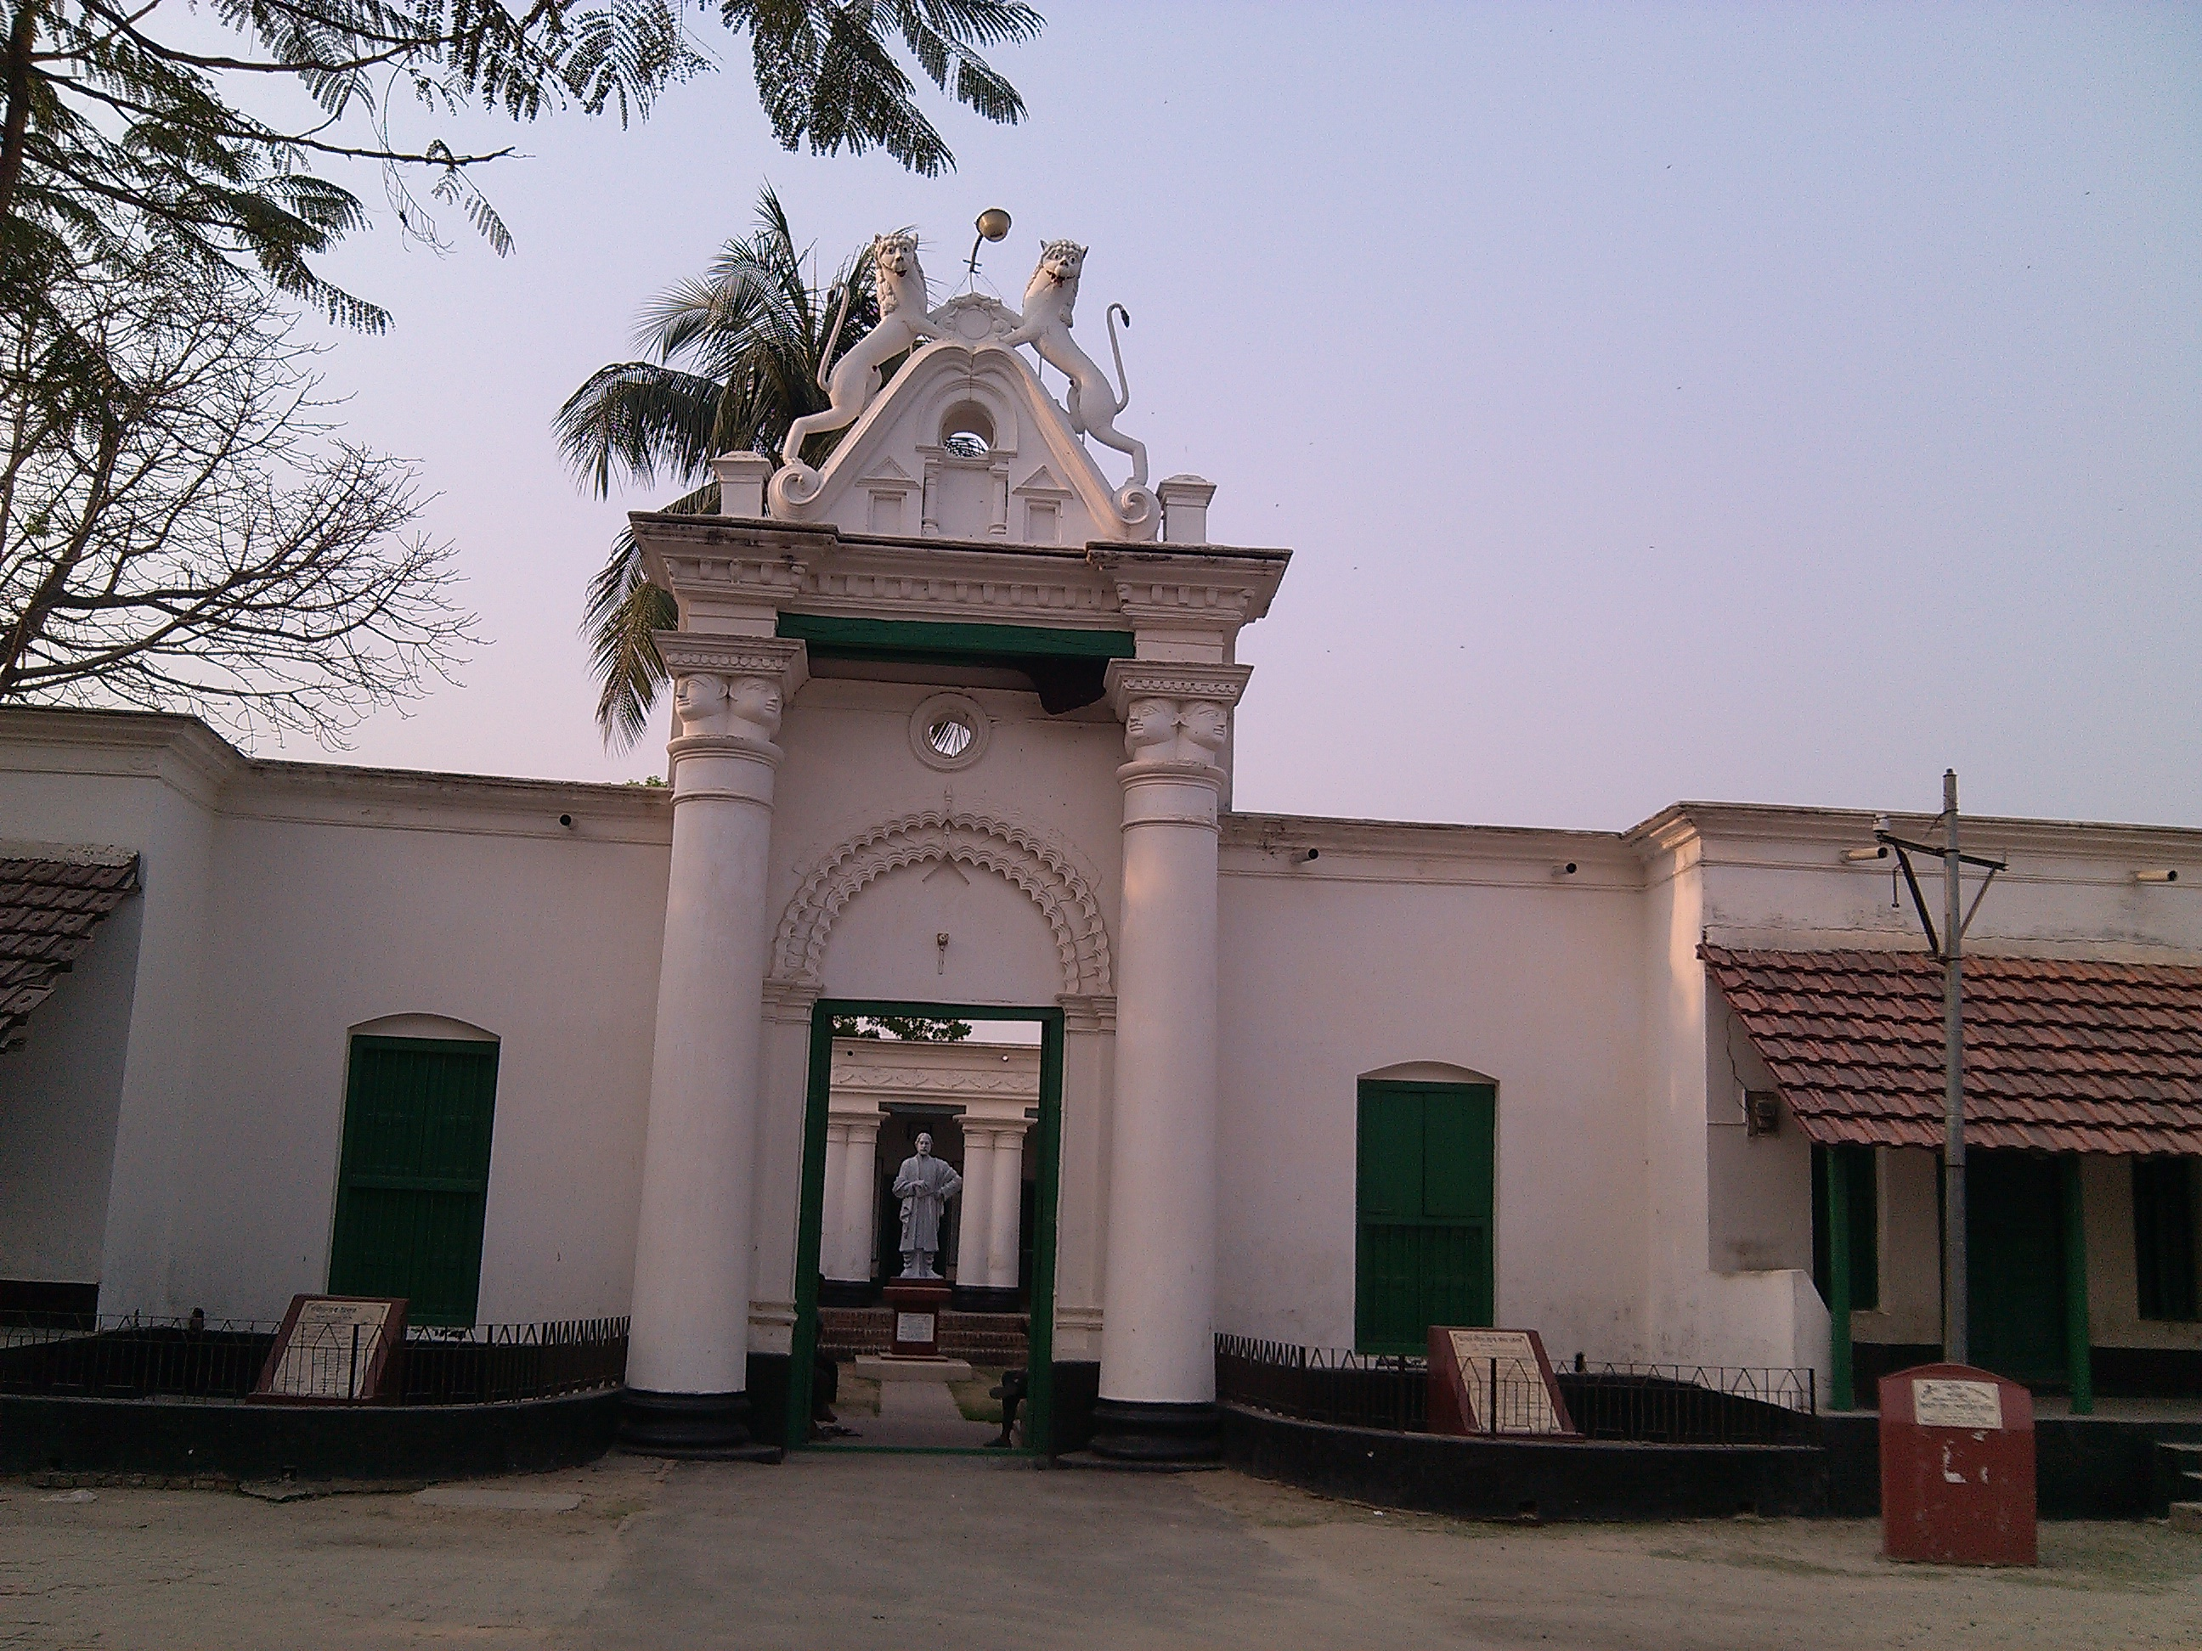

Rabindra Kuthi Bari at Patisar, Atrai, Naogaon

