**ORGANIZATIONAL CHART OF HILIP**

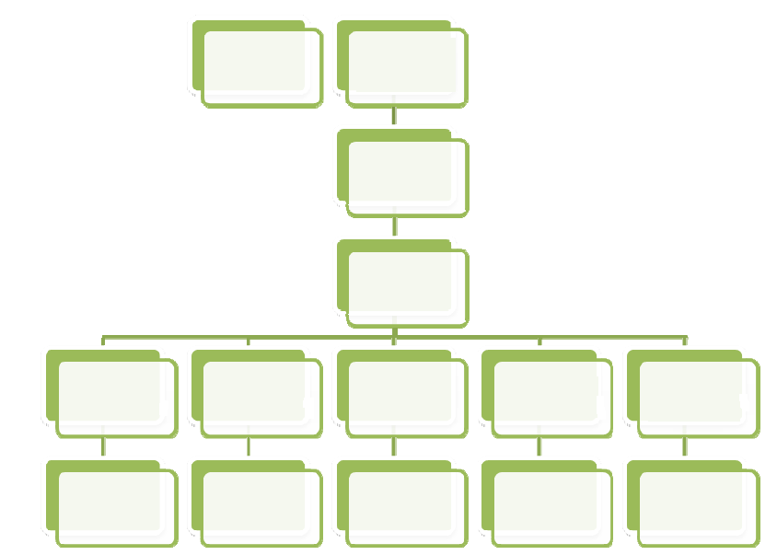

**Local Government Division (IMPSC)**

**IFAD**

**LGED**

**PMU (Dhaka)**

**LGED (EXEN)- DMU Netrokona**

**LGED (EXEN)- DMU Sunamganj**

**LGED (EXEN)- DMU Habiganj**

**LGED (EXEN)- DMU Kishoreganj**

**LGED (EXEN)- DMU Brahman Baria**

**UMU (2)**

**UMU (3)**

**UMU (3)**

**UMU (4)**

**UMU (2)**