cwi`k©b cÖwZ‡e`‡bi Av‡jvKwPÎ

1| | 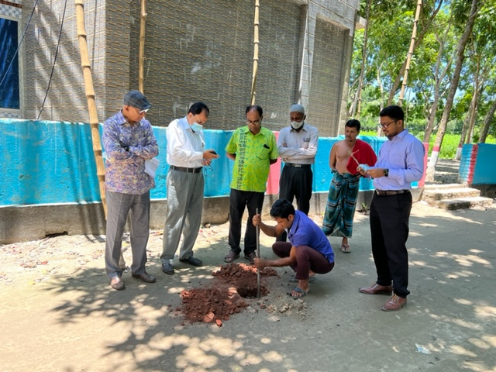 | 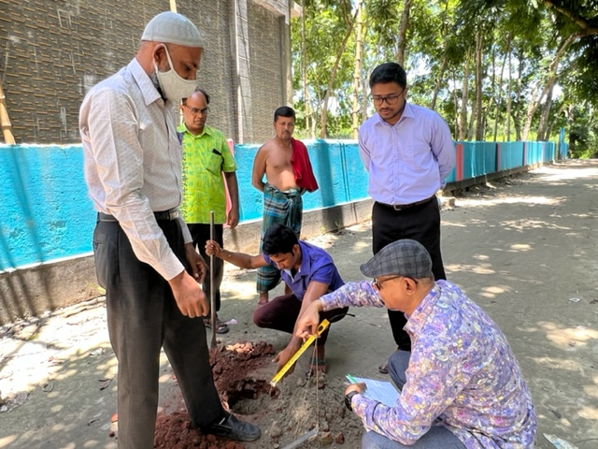
 | Av‡jvKwPÎ-01 | Av‡jvKwPÎ-02
 | 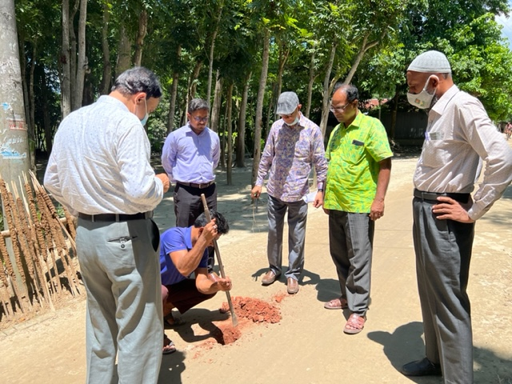 | 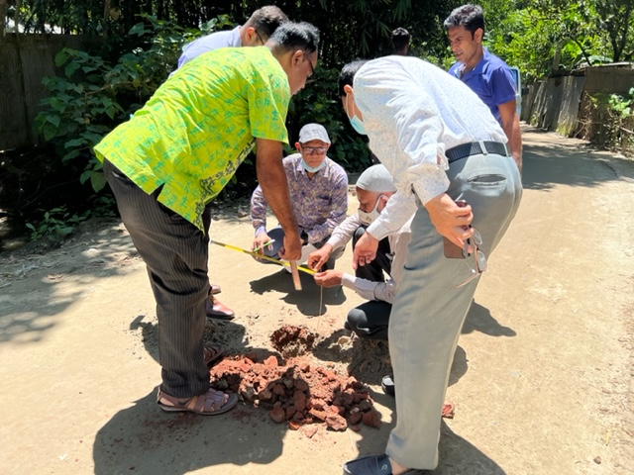
 | Av‡jvKwPÎ-03 | Av‡jvKwPÎ-04

2| | 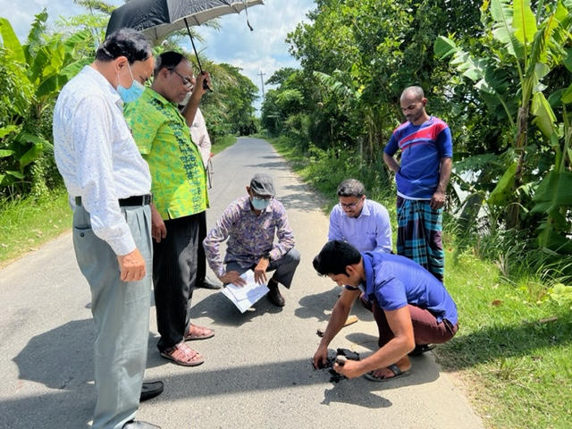 | 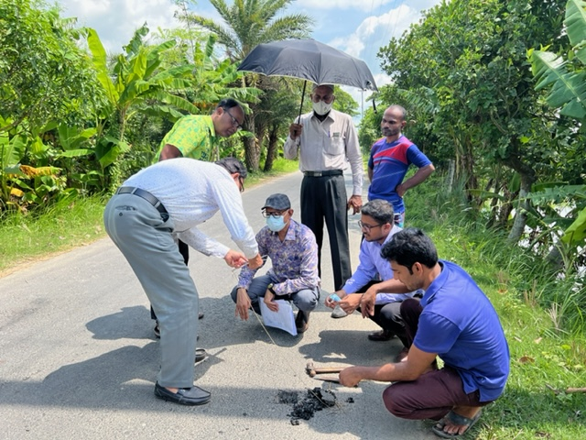
 | Av‡jvKwPÎ-05 | Av‡jvKwPÎ-06
 | 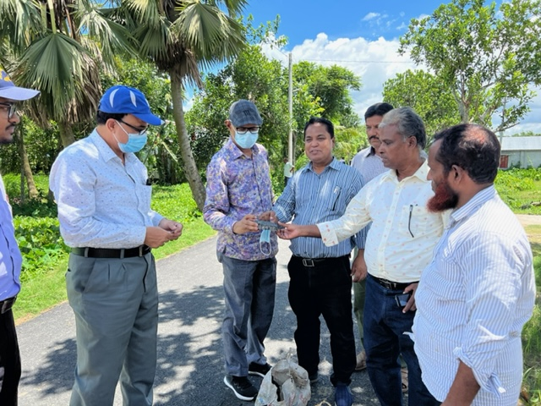 | 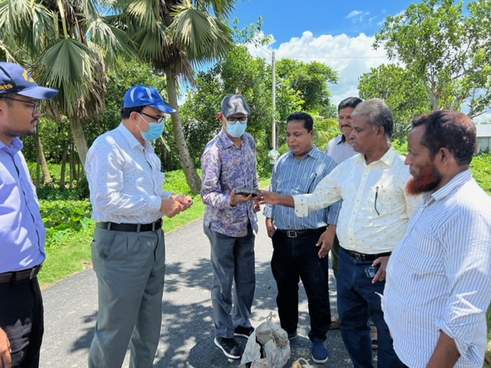
 | Av‡jvKwPÎ-07 | Av‡jvKwPÎ-08

3| | 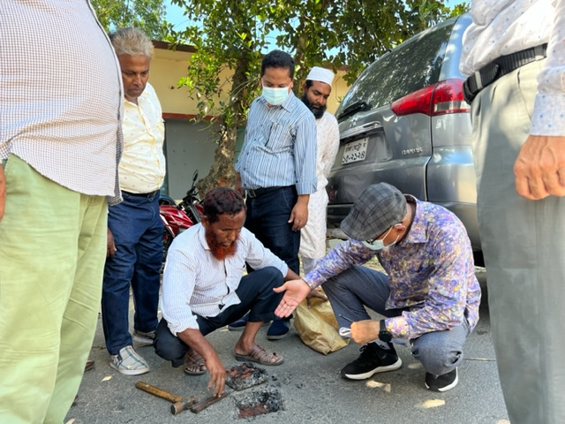 | 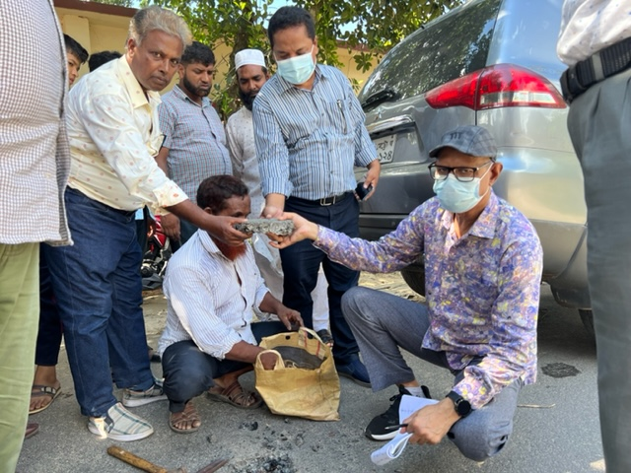
 | Av‡jvKwPÎ-09 | Av‡jvKwPÎ-10
 | 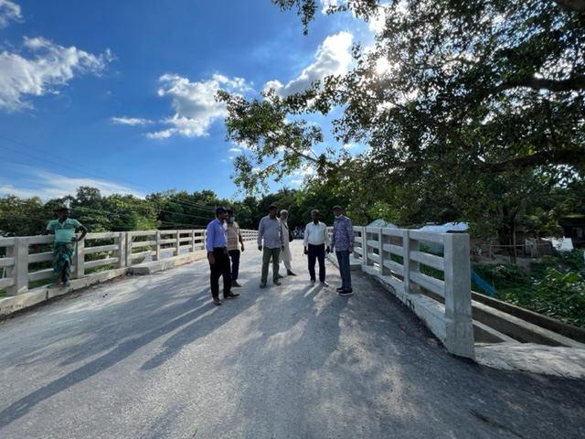 | 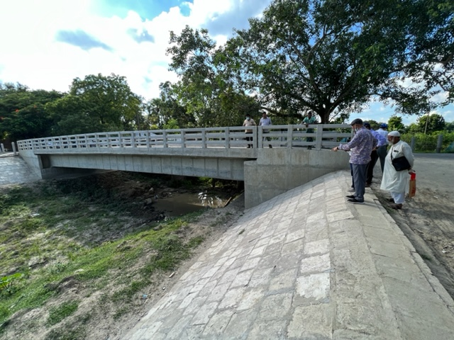
 | Av‡jvKwPÎ-11 | Av‡jvKwPÎ-12

(‡gvt ‡gv¯ÍvwdRyi ingvb)
cÖKí cwiPvjK
‡dvbt 02-48118390
pd.kdridp@lged.gov.bd

