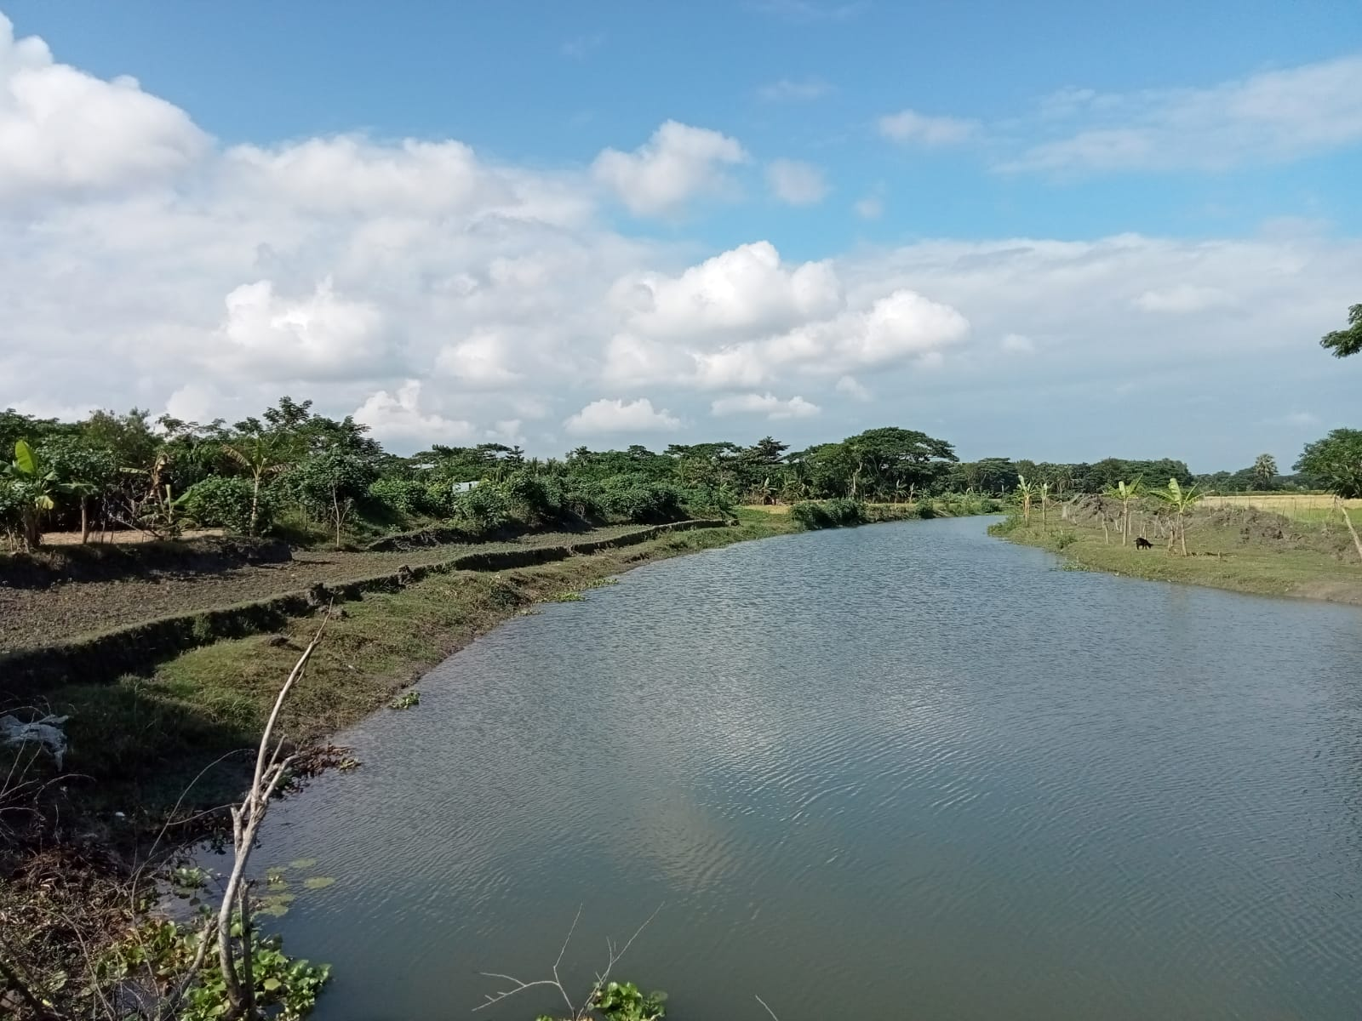

**IPCP/BHOL/LALMO/C/19-20/9.07**

Burir Done Khal Lalmohan, Bhola

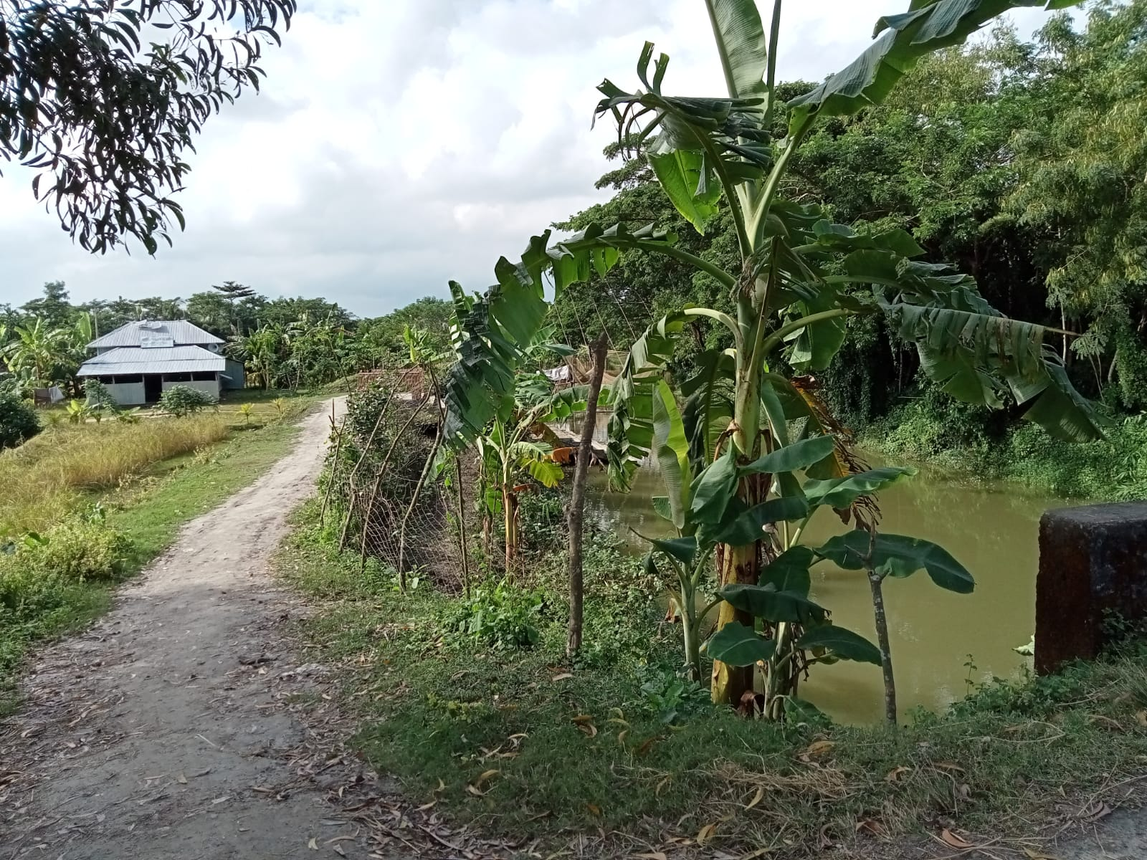

**IPCP/BHOL/LALMO/C/19-20/9.07**

Burir Done Khal Lalmohan, Bhola

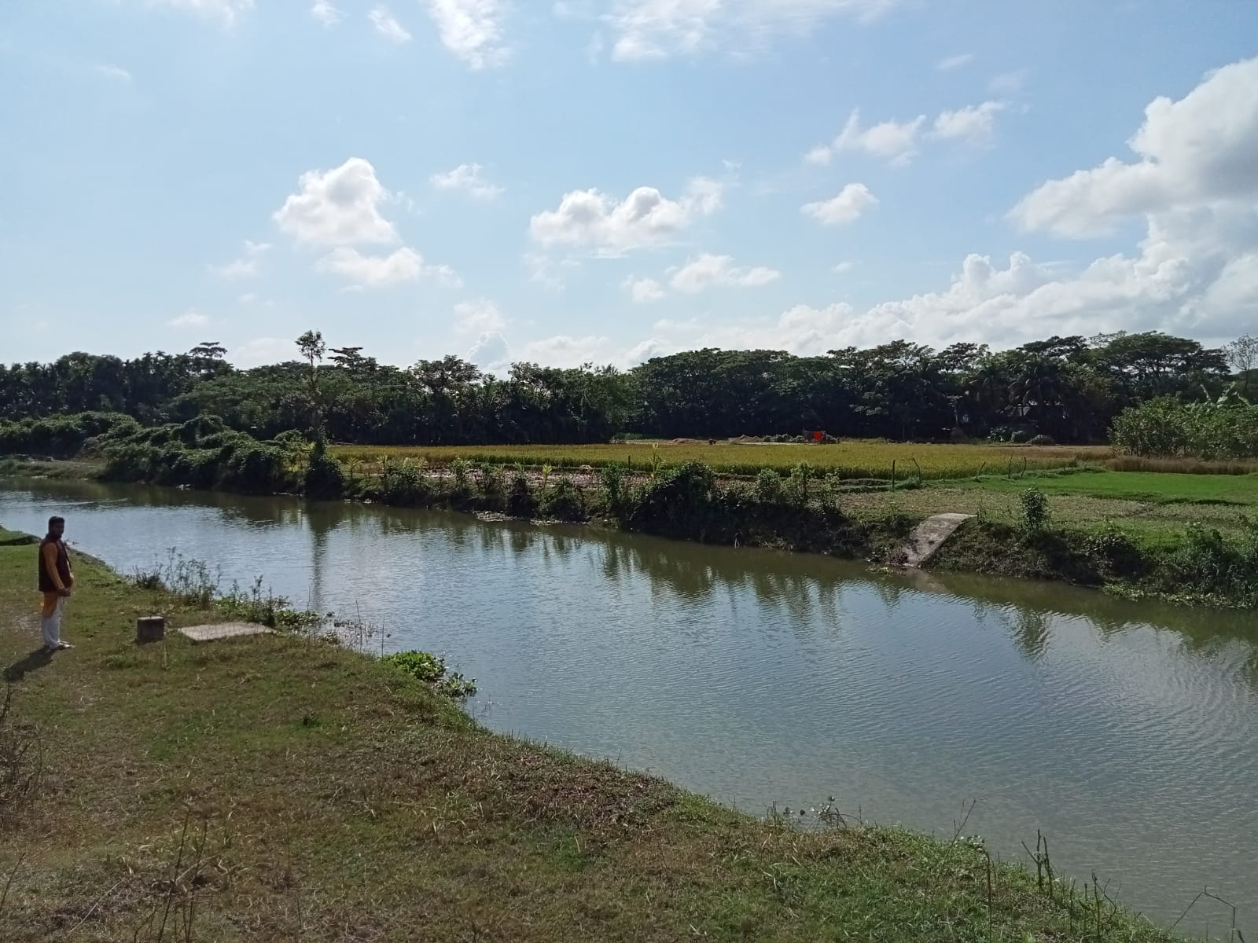

**IPCP/BHOL/LALMO/C/19-20/9.07**

Burir Done Khal Lalmohan, Bhola

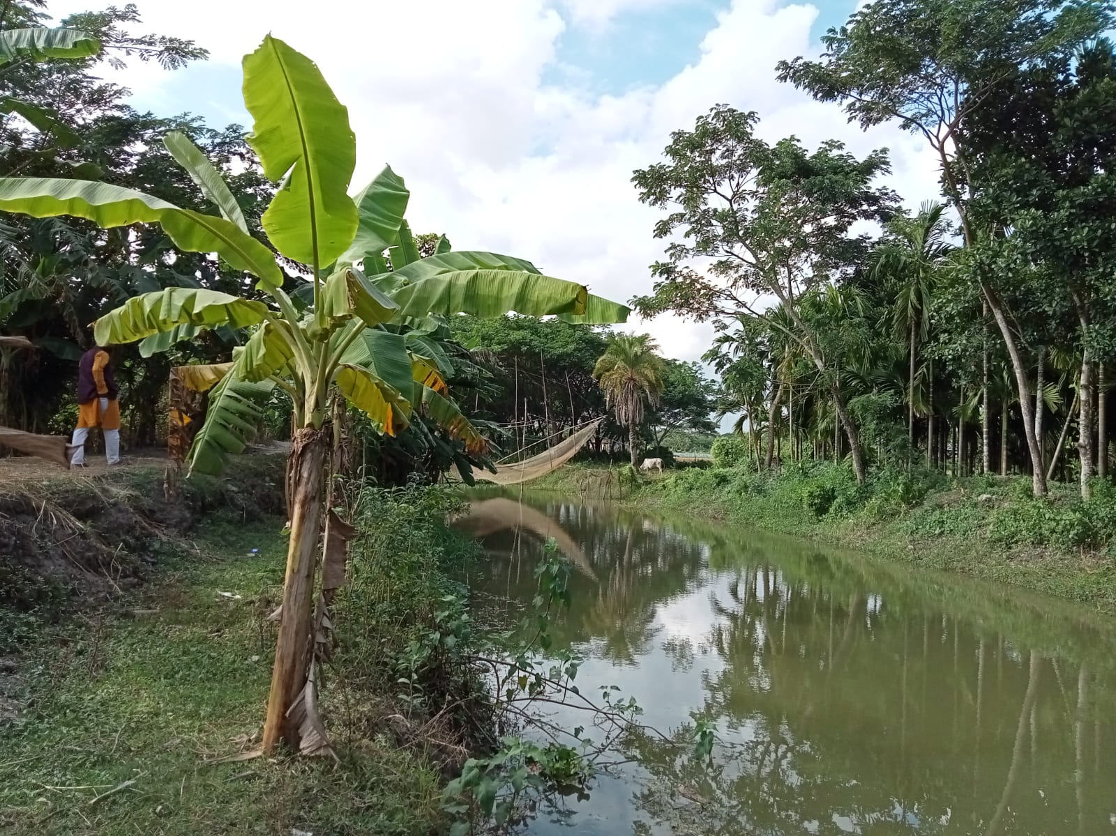

**IPCP/BHOL/LALMO/C/19-20/9.07**

Burir Done Khal Lalmohan, Bhola

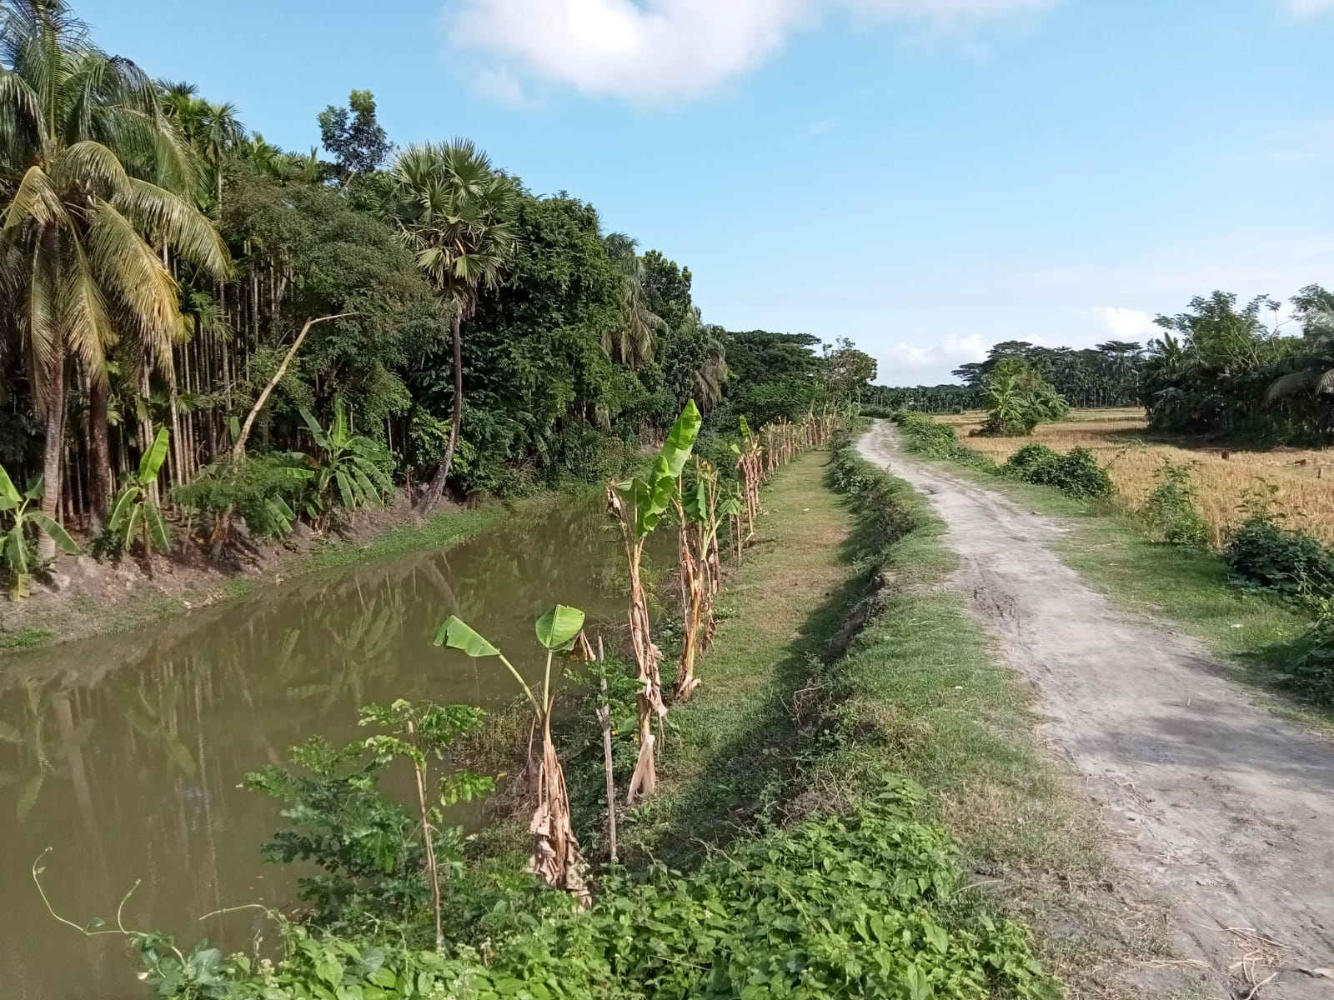

**IPCP/BHOL/LALMO/C/19-20/9.07**

Burir Done Khal Lalmohan, Bhola

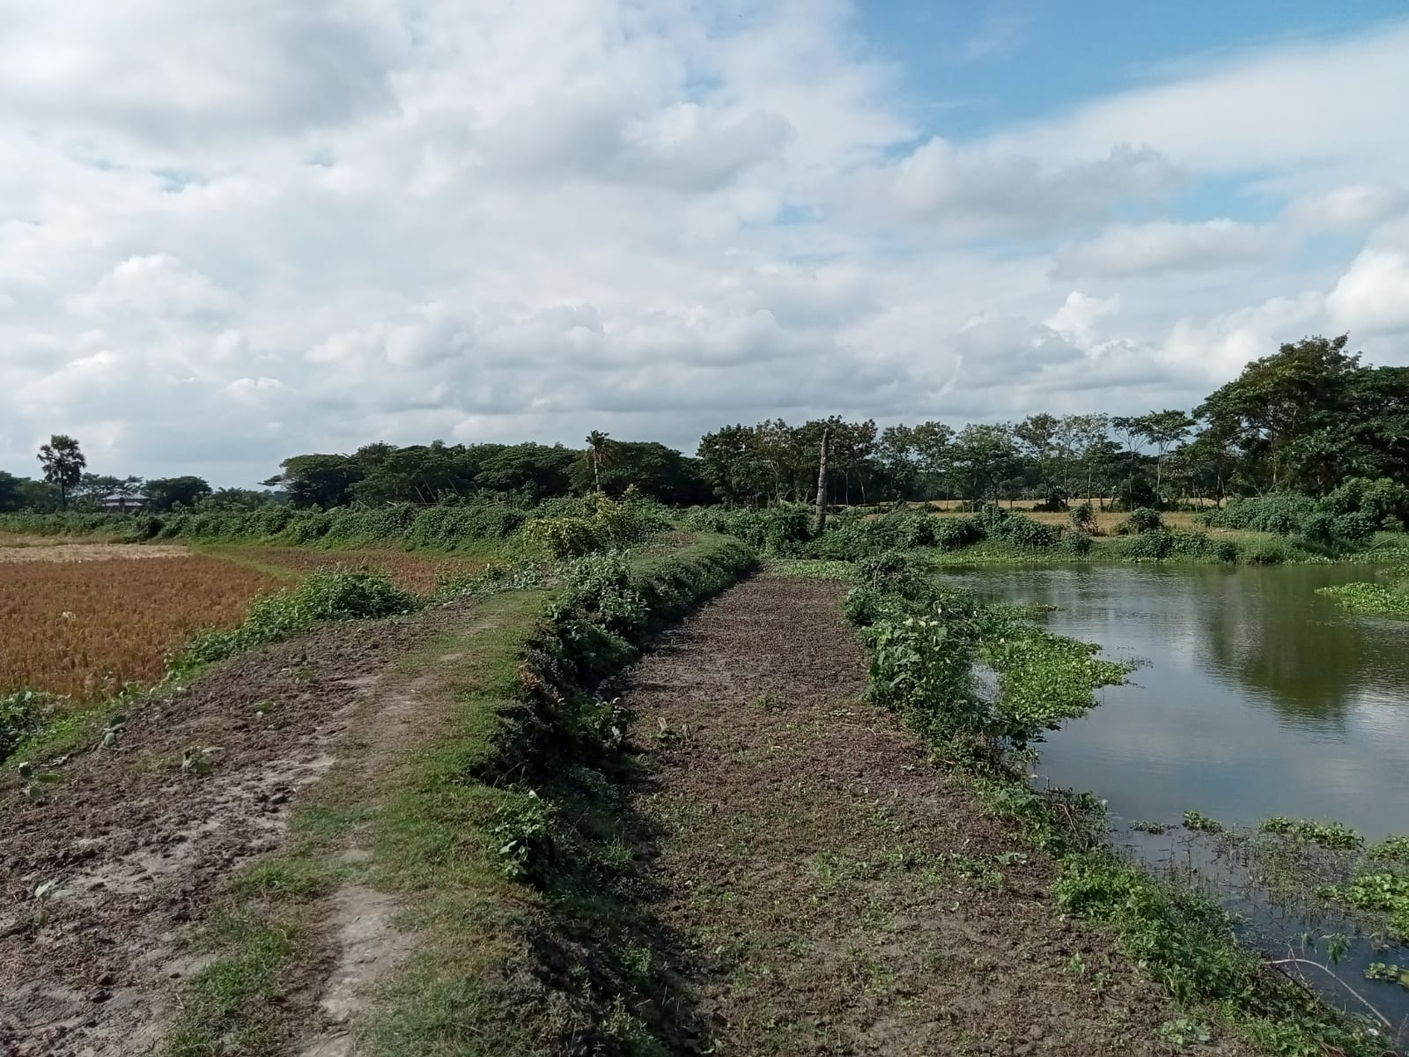

**IPCP/BHOL/LALMO/C/19-20/9.07**

Burir Done Khal Lalmohan, Bhola

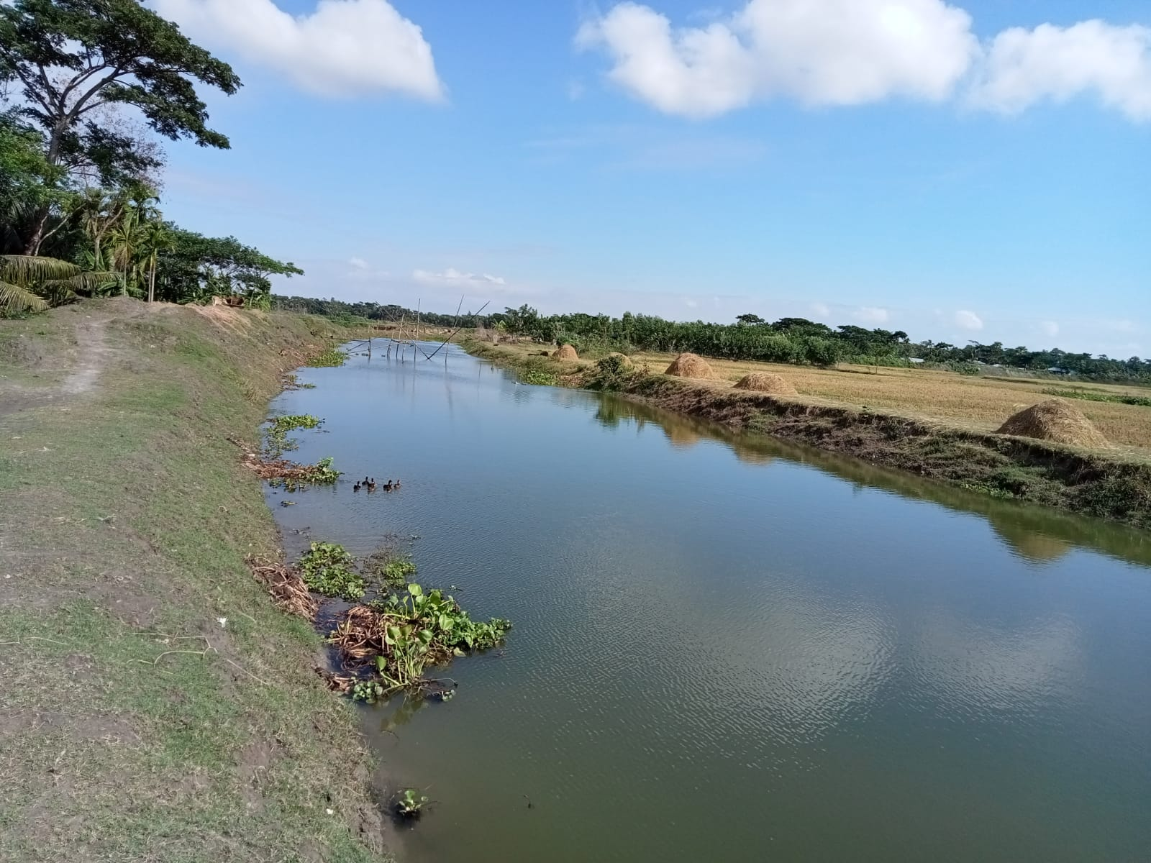

**IPCP/BHOL/LALMO/C/19-20/9.07**

Burir Done Khal Lalmohan, Bhola

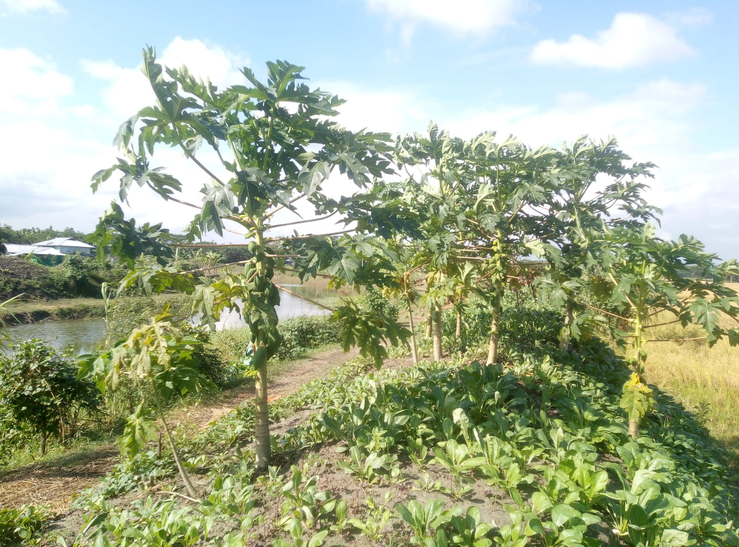

**IPCP/BHOL/LALMO/C/19-20/9.07**

Burir Done Khal Lalmohan, Bhola