LOCAL GOVERNMENT ENGINEERING DEPARTMENT

PARTICIPATORY SMALL SCALE WATER RESOURCES

SECTOR PROJECT (PSSWRSP)

Bangladesh Loan (ADB) No.2542 BAN (SF), IFAD Loan No. 786/808

FINAL REPORT

ON

KNOWLEDGE, ATTITUDE AND PRACTICES

(KAP) SURVEY

Prepared by

N. CHAKRAVORTY

KAP Specialist

August 31, 2016

FINAL REPORT

ON

KNOWLEDGE, ATTITUDE AND PRACTICES (KAP) SURVEY

TABLE OF CONTENTS

EXECUTIVE SUMMARY 06

I INTRODUCTION 10

I.1 Background 10

I.2 Objectives of KAP Survey 10

II APPROACH AND METHODOLOGY 11

II.1 The Approach 11

II.2 Methodology 11

II.3 Review of Important Relevant Documents 16

II.4 Nature of PSSWRSP Intervention and Relevance of KAP 18

II.5 Limitation of the Study 19

III FIELD WORK PLANNING 21

III.1 Design of Household Data Collection Instruments 21

III.2 Field Data Collection and Quality Maintenance 21

III.3 Design of KII and Checklist 22

IV DATA MANAGEMENT 23

IV.1 MS Excel Database Design 23

IV.2 Data Tabulation and Analysis 23

V PRESENTATION OF SURVEY DATA AND ANALYSIS 24

V.1 General Information 24

V.1.1 Sample Subproject List with Typology 24

V.1.2 Training Providers in PSSWRSP of LGED 24

V.1.3 Location Map of Survey Universe 25

V.2 Agriculture Related KAP Information 26

V.2.1 Demographic Information on Sample Agricultural Trainee Households 26

V.2.2 Training Frequency and Venue Condition 26

V.2.3 New Knowledge Learnt, Applied and Effect 27

V.2.4 Field Day Participation Profile 29

V.2.5 Knowledge about Difference between Demo and Normal Farm 30

V.2.6 KAP of Crop Planning 31

V.2.7 Reported Effect of Training on Income 31

V.2.8 Allied Training Information 32

V.2.9 Knowledge and Practice of Homestead Crops 32

V.2.10 Practice of Evaluation of Agricultural Trainers 33

V.2.11 Need for Additional training 34

V.3 Fisheries Related KAP Information 35

V.3.1 Demographic Information on Sample Fisheries Trainee Households 35

V.3.2 Training Frequency and Venue Condition 35

V.3.3 New Knowledge Learnt and Applied 37

V.3.4 Knowledge and Practice of New Fish Culture 38

V.3.5 Knowledge of Avoiding Fish Health Hazard 39

V.3.6 Knowledge of Fishery Program Management and its Application 39

V.3.7 Knowledge and Practice of Rice-Fish Culture 40

V.3.8 New Knowledge and Practice Dynamics and Increased Income 40

V.3.9 Practice of Evaluation of Fisheries Trainers 41

V.3.10 Respondents' Reason of Taking Fishery Training 42

V.4 Basic Cooperative Management Related KAP Information 42

V.4.1 Training Frequency and Major Training Topics 42

V.4.2 Bye-Law Preparation and Use Profile 44

V.4.3 WMCA Registers Regularity 45

V.4.4 AGM Report and Proceedings Writing Practices 45

V.4.5 Sub-committee Operational Status 45

V.4.6 Knowledge of Audit and Accounts Registers Maintenance 46

V.4.7 Status of Cooperative Inspectors' Visit to WMCAs 46

V.4.8 Knowledge and Practice of Annual Report Preparation 46

V.4.9 Attitude towards Importance of Cooperative Management Training 47

V.4.10 Training Material Use and Efficiency 48

V.4.11 Attitude towards Special Knowledge Need 48

V.4.12 Attitude to Member Education Program and its Benefit 48

VI CONTROL AREA DATA AND INFORMATION 49

VI.1 Control Area Respondents' KAP of Agriculture 49

VI.1.1 Demographic Profile 49

VI.1.2 Training Information 49

VI.1.3 HYV Practices 49

VI.1.4 Benefits of Training 49

VI.1.5 Knowledge and Practice of Annual Crop Planning 50

VI.1.6 Knowledge and Practice of Homestead Crops 51

VI.I.7 Control Area Attitude towards PSSWRSP Agricultural Training 51

VI.1.8 Comparison between KAP of Project and Control Area 51

VI.2 Control Area Respondents' KAP of Fisheries 52

VI.2.1 Demographic Profile 52

VI.2.2 Fish Cultivation Profile 52

VI.2.3 Fisheries Knowledge, Attitude and Practice 53

VII SUMMARY OF KAP SURVEY FINDINGS 55

VII.1 KAP Rating Chart for Agriculture 55

VII.2 KAP Rating Chart for Fisheries 56

VII.3 KAP Rating Chart for Basic Cooperative Management 57

VIII CONCLUSION AND RECOMMENDATIONS 58

List of Tables
- KAP Analysis Matrix
- Topography, Population, Benefited Area of KAP Survey Universe
- Sample Distribution, Type of Subproject and Household Characteristics
- Project Interventions, Description and KAP Relevance
- Field Survey Work Distribution
- Demographic Information: Sample Area Trainee Households
- Total Training Received by Sample Trainee Households per Sample SPs
- Demographic Information: Sample Fisheries Training Households
- Fisheries Training Modules Delivered (2012-2015) in Sample 4 SPs
- Knowledge of Trainees about Fish Health Risk Management
- Schedule of KII with Sample WMCA Bodies
- Status of Performance of Selected SPs
- Control Area Demographic Profile of Agricultural Trainee/non-Trainee HHs
- Percent of People with Knowledge and Practice in Project and Control Areas
- Control Area Demographic Profile of Fisheries Trainee/non-Trainee HHs

List of Figures
- Training Received per SP
- New Knowledge and Number of Trainees
- Trainee Number per SP
- Field-Day Participation Profile
- Training Materials Used in Field-Day
- Knowledge about Difference between Demonstration and Normal Farm
- Knowledge and Practice of Crop Planning and Use
- Respondents' Reason for Increase in Income
- Number of Training on Allied Training Topics
- Percent of Trainees in Homestead Crop Practice
- Income Increasing Factors through Homestead Cropping
- Trainer Evaluation Practice
- Trainer Evaluation Modality
- Topics of Additional Training Needed
- Number of Trainees Mentioning Materials Used by Trainers
- New Knowledge and Practice Levels of Trainees
- Different Fish Species Cultural Practices
- Fishery Management Practice Levels
- Knowledge and Practice of Rice-Fish Culture
- Number of Trainees Mentioning Causes of Increased Income
- Fisheries Training Evaluation Profile
- Total Training Received on BCM per WMCA
- Number of WMCAs Receiving Various Modules of BCM Training
- Bye-Law Preparation and Use Profile
- Sub-Committee Operation Status
- Cooperative Inspectors' Visit Status
- Annual Report Preparation Knowledge and Practice Status
- Perception about Importance of BCM Training
- Number of WMCAs Demanding Special Knowledge
- Benefits of Training in Control Area
- Control Area Knowledge on Crop Plan Preparation
- Control Area Homestead Crop Growing Practice
- Control Area Pond Owning Status
- Control Area Fish Culture Profile

ACKNOWLEDGEMENTS

A KAP Report as this inevitably draws from and builds on the training activities that has been accomplished through Participatory Small Scale Water Resources Sector Project(PSSWRSP), being implemented by Local Government Engineering Department (LGED) and supported by ADB, IFAD and the Government of the People's Republic of Bangladesh. But it is the first of its kind in Bangladesh water sector. Therefore, I acknowledge my gratitude to all involved in PSSWRSP implementation for their cooperation.

Particular thanks to Engr. Mr. Md. Shahidul Haque, earlier Project Director, PSSWRSP who

had initially helped me to understand the scope through a vibrant discussion during presentation of KAP Inception Report in early February, 2016 and was continuing to show interest in the survey when he was promoted and posted elsewhere.

His successor, Engr. Mr. Md. Sheikh Nurul Islam, Project Director, PSSWRSP equally deserves special thanks for his all out support and assistance to the field survey and other allied works during this report preparation. My sincere thanks are also to all Officers of PMO: Engr. Mr. Anil Chandra Barman, Executive Engineer (Implementation),; Mr. M. Momtaz Haider, Sr. Socio-economist; Mr. Md. Sohrab Hossain Khan, Sr. Agriculturist and Mr. Shankar Chandra Sutradhar,Sr. Aqua-culturist for their professional support during survey and report preparation. All Field XENs in respective districts and Upazilas under the survey also deserve sincere thanks for their logistic and other professional support to this study.

My gratitude is due to all experts who kindly provided patience and time for me from Rural

Development Academy (RDA),Bogra;Bangladesh Academy for Rural Development (BARD), Kotbari, Comilla; Bangladesh Cooperative Academy (BCA), Kotbari, Comilla, Sher-e-Bangla Cooperative Zonal Institute (CZI), Barisal and Fish Seed Multiplication Farm, Baghata, Narsingdi. Names of experts from all these institutions are appended at Appendix-5 of this report.

Facilitators engaged in different subproject also worked hard to collect data from households

during KAP survey. All of them deserve thanks for their rigorous work.

Mr. AKM Nazmul Hasan, Research Assistant for this survey also deserves thanks for his data entry and other associated work.

I thank about 500 participating interviewees of the sample 12 WMCAs under survey

who kindly gave time and energy to accomplish the questionnaire survey successfully.

This Final version of KAP survey report addresses very valuable comments made by wise participants in the workshop held on August 7, 2016.

ABBREVIATIONS AND ACRONYMS

ADB Asian Development Bank

AGM Annual General Meeting

BARD Bangladesh Academy of Rural Development

BCA Bangladesh Cooperative Academy

BCM Basic Cooperative Management

BETS Bangladesh Engineering and Technology and Services

CA Community Assistant

CDP Capacity Development Plan

CZI Cooperative Zonal Institute

DAE Department of Agricultural Extension

DoC Department of Cooperatives

DoF Department of Fisheries

DR & IRR Drainage and Irrigation

DR & WC Drainage and Water Control

FGD Focus Group Discussion

FM & WC Management & Water Control

FMD & IRR Flood Management & Irrigation

GoB Government of Bangladesh

HH Household

IFAD International Finance for Agricultural Development

IGA Income Generating Activities

KAP Knowledge, Attitude and Practice

KII Key Informant Interview

LGED Local Government Engineering Department

MIS Management Information Services

PIC Project Implementation Consultants

PMO Project Management Office

PSSWRSP Participatory Small Scale Water Resources Sector Project

RDA Rural Development Academy

SP Subproject

SSW-1 Small Scale Water-Phase-1

SSW-2 Small Scale Water-Phase-2

ToR Terms of Reference

ToT Training of Trainers

WC Water Control

WMCA Water Management Cooperative Association

EXECUTIVE SUMMARY

This is the first ever KAP survey report on PSSWRSP, a pioneering exercise in water sector at large in Bangladesh. Its beginning has unfolded the mine of information from different sources: WMCAs, LGED officials, Training providers and Control population. To capture the data and information from hitherto scattered sources and to bind them in manageable bundles was a challenge for this study. LGED management has aptly succeeded in meeting the challenge and finally in coming out with a concrete KAP report.

Training has been the starting point of delivering knowledge, facilitating change in attitude and initiating practice. So far, 11 modules for agriculture, 7 modules for fisheries and 10 modules for basic cooperative management have been delivered in different training institutes and centers from 2012 to 2015. Based on these deliveries levels of knowledge, attitude and practices have changed over time. Objective of this KAP survey has been to take a quick stock of KAP levels through a sample survey in Barisal Division as designed in the ToR for the consultant.

Starting in February, 2016 the survey was completed in mid March and report completed in end March. The survey was conducted on 9 subprojects out of 20 in Barisal division. Criteria for selection were:

- hydraulic infrastructure was completed by late 2013; and
- Training has been conducted before late 2013 for agriculture and fisheries and up to mid-2014 for institutional development.

Two stage random sampling method was followed and sample size as per Raosoft sampling method was 380 (30 households of Bhola were dropped later as no trainee was available) . Additional 50 households were surveyed from the control area (for comparison with values of project KAP variables). Facilitators engaged in 9 subprojects worked as enumerators, collecting information using pretested questionnaire. About 15000 fields were entered with survey data in pre-designed excel program of the computer. Results were analyzed with the help of interactive tables, graphs and charts.

Important observations on the basis of analysis have been marked in italics instantly in paragraphs of each section so that management can throw their eyes on them and find the issues to be addressed.

Control area information have not been used so much for comparison as those data almost match the project area data because of KAP-spills from subprojects into almost all the 4 fisheries and 12 agricultural control villages (for details see section VI.1.8 below).

Major findings are:

- Training has improved knowledge, attitude and practice domains of subproject beneficiaries by way of improved agriculture, fisheries and cooperative management. Rates of improvement are different: all sectors are scoring medium and high levels for almost all KAP variable except very few scoring medium and low performance (see KAP score Chart below).
- Appropriate trainees with minimum required education/literacy and interest have to be selected from among subproject beneficiaries. Official instructions defining selection criteria are found in memorandums issued by monitoring office. A strict follow-up of the criteria in the field and its monitoring remains a task for field level monitors.
- Women's demand for specific training on Ape culture, sewing, homestead nursery, poultry etc. is increasing and provision for further training is underscored during survey.
- Trainer and trainee evaluation process require a thorough review and appropriate means to be devised for regular and formal evaluation instead of the current informal and verbal one.
- Institutional practices e.g. WMCA office management and secretarial tasks requires close monitoring and on-site mentoring of office bearers with practice-oriented exercise (for the executives and sub-committee members) instead of dry-swimming instructions.
- District and Upazila Engineers can have better monitoring handles by using Training completion reports. But the reports now have scanty or no handle as such. For example, training completion reports may outline after-training schedule of tasks for the trainees in respective trades/modules which can act as a monitoring instrument for reviewers. These will improve attitude and practice levels.
- Accounting module needs revision, for which a revised 3-Day module is proposed and appended with this report.

In view of the findings of the study and opinions arising from FGDs and interviews with experts in different training institutions, following few practical recommendations for attaining improved KAP levels are made for the management to consider and intervene to see that training program is effective:

For PMO/LGED
- Agricultural and fisheries training are conducted using Training Modules prepared as back as in 2005/06. RDA, BARD and LGED jointly developed Manuals and Modules for agricultural training which are aptly serving the purpose, but the older ones of LGED have to be updated and new issues integrated into those old Modules with a view to internalizing the developments within LGED which remains the pivot of training there as a sustainable process.

- Basic cooperative modules also need review with respect to accounts management, microcredit and secretarial practices. A revised 3-Day (instead of current 2-Day model) Accounts Management module is suggested (see Appendix-9).
- Accounts register formats now being used by many WMCAs are not entirely compatible with Cooperative's standard format. Coordinated format has to be devised in line with the standard of Department of Cooperatives.
- Instructions from PMO about selection of trainees need to be strictly pursued so that trainees with appropriate background (in line with what he/she is going to learn) and adequate interest to learn. RDA, Bogra has specifically reiterated this issue for meaningful delivery of knowledge and skill.
- Poverty reduction planning exercise during training in BARD and RDA need to be tagged with final plan (Plan Book) preparation exercise by participants themselves at respective trainee environment and locations. Necessary arrangements have to be made for Experts/Trainers to attend or check final outputs of trainees.
- Most needed training modules (e.g. bee culture, sewing, poultry, livestock) as demanded by potential trainees may be arranged from relevant organizations to cater the current needs.
- Sequencing the training events for a particular trainee group in a particular module is essential so that no module is left incomplete and sending the same group of trainees to each event has to be rationalized. General members (except executives) of WMCAs have to be increasingly encouraged to receive trainings on agriculture and fisheries.
- Training modules need to include more practice-oriented sessions, particularly in basic cooperative management topics.
- The job descriptions of General Facilitators,. Agricultural Facilitators and Fisheries Facilitators are quite extensive. All positions have been given responsibility for monitoring WMCA capacity development levels. Field observations during the survey particularly point to the need for developing monitoring instruments for them to use for performing the responsibility.
- Sorting of weak WMCAs is to be initiated and those have to be strengthened through adequate training and exchange of experience with strong WMCAs (through visit and interaction between week and strong WMCAs like CVDP-based projects and nationally rewarded WMCAs.
- If qualified WMCA executives are not found interested or eligible from quality point of view, literate and interested non-executive common members of the WMCA may be picked and given TOT courses for efficient delivery of knowledge on the spot on demand.
- Coordination between Training providers and PSSWRSP need to be reinforced through quarterly or semi-annual meetings at appropriate locations for filling laps and gaps from time to time.
- Finally, improve the existing database format may be improved with important KAP variables in MIS of PSSWRSP to enable management to review the KAP situation from time to time and intervene efficiently to improve project outcomes.

For District and Upazila Enginnering Offices/LGED

- The source and quality of data entered in Quarterly Institutional Development Report form has to be checked from time to time. Essential data fields should not be left blank or inadvertently entered.
- In monthly or quarterly review meetings, the Engineers may check training data from Facilitators and review attitude and practice level performances of trainees
- Upazila Engineers may make surprise visits to any WMCA area to check any reported fact on the ground related to KAP
- Engineers can use the KAP score chart format of this report for random checking of training effects on important KAP variables

For Training Institutes

Providers of training for WMCAs of PSSWRSP are national institutions and rendering invaluable services towards attaining the project objectives. They may consider the following for improving practices on the ground and helping the Project in achieving its objectives:

- Outline a concrete task list for the trainees for each module (if needed) in one course and ask them to practice those in their own environment. This list may be published in the course completion report they prepare.

This outline may be transmitted to respective District/Upazila Engineers by respective Facilitators/ CAs for follow-up in review meetings.
- Include quality of trainee selection in Course Completion Report for every

training course.
- Check course appropriateness for particular types of trainees and relevance of the course to earlier course (s) delivered.
- Ensure trainee and trainers evaluation in every training event.
- Ensure that improved and effective training materials are used by Trainers.

I. INTRODUCTION

I.1 Background

The Participatory Small Scale Water Resources Sector Project (PSSWRSP), being implemented by the Local Government Engineering Department (LGED), includes an extensive capacity building program across all subproject activities. This capacity building program provides training courses which are the principal means by which the project supports capacity development. Training program addresses three domains of human development: knowledge, Attitude and Practice (KAP).

The project training program at large is conducted in 61 districts of Bangladesh (except 3 hilly districts) to implement 270 new subprojects and enhance performance of old 150 subprojects under PSSWRSP. But this KAP survey has been limited to include new subprojects implemented in 6 districts in Barisal Division: Barguna, Bhola, Barisal, Jhalokati, Pirojpur and Patuakhali (see the KAP survey district map below) where WMCA members have been trained in capacity building, specifically in WMCA establishment and development, agriculture and fisheries (see Appendix-1, ToR, section-3 (objectives). These trainings have been conducted mainly by LGED, Department of Agricultural Extension (DAE), Department of Fisheries (DoF) and Department of Cooperatives (DoC). It is important to note that all subprojects are mandatorily registered with the Department of Cooperatives as Water Management Cooperative Association (WMCA), an entity to foster dynamic leadership backed by continuous training and evaluation.

As per ToR (see Appendix-1), the criteria for subproject selection for KAP survey within the aforesaid 6 districts have been for those where:
- hydraulic infrastructure was completed by late 2013; and
- training has been conducted before late 2013 for agriculture and fisheries and up to mid-2014 for institutional development.

Twenty such subprojects met these criteria. Each subproject covers benefited area up to 1000 ha. In this survey, training conducted during 2015 has also been included by default.

I.2 Objectives of KAP Survey

The broad objectives of KAP survey have been described as follows:

- to evaluate the effectiveness of the PSSWRSP capacity building program in WMCA establishment and development, agriculture and fisheries training activities, and
- to use the KAP survey results and analysis to recommend areas of intervention to ensure that the training is effective and sustainable for beneficiary development

II. APPROACH AND METHODOLOGY

II.1 The Approach

The survey has been carried out using both quantitative and qualitative approaches. The quantitative approach includes administering pre-designed structured questionnaire and qualitative approach includes Key Informant Interviews (KII) and discussions with knowledge tanks in concerned training institutes.

II.2 Methodology

Proposed KAP survey methodology involves both qualitative and quantitative responses. It includes three types of surveys:

- Household Surveys (HHs)
- Key Informant Interviews (KII)
- Limited Control Area KAP information collection through Questionnaire Survey (as there is no baseline KAP information)

The survey types and detailed methods followed are described below:

Household Surveys:

Training beneficiary Household Surveys (HHS) on KAP have been conducted for agriculture and

fisheries;

Key Informant Interviews:

The elected representatives of WMCA along with Accountants, Cashiers, Community Assistants and Organizers have been the first group interviewed to collect data and information on basic cooperative management knowledge, attitude and practices.

The next groups interviewed are the concerned training experts (conducted after initial results of the HHS are known) in National Training Institutes like Bangladesh Academy for Rural Development (BARD), Comilla; Bangladesh Cooperative Academy (BCA), Comilla; Rural Development Academy (RDA), Bogra; Sher-e-Bangla Zonal Cooperative Institute, Barisal; District Fisheries Training Institute, Narsingdi and LGED Resource persons.

Control area information collection through questionnaire survey:

Control area data have been collected from households in villages selected from the neighboring

areas of sample Subprojects surveyed. Every household was exposed to such survey to avoid

selection bias. Separate questionnaire for control area survey have been designed to capture only

essential KAP information, amenable to comparison with Subproject information.

No household survey has been conducted for basic cooperative management issues for the Control

area. The above methodology is transposed below in 3x4 matrix to further clarify the definition of

knowledge, attitude and practice vis-a-vis tools for observation, analysis and assessment criteria

used in this study. The training effectiveness has been viewed through KAP prism using tools in

three columns below:

Table-1: KAP Analysis Matrix
 | Definition | Observation | Analytical Tools | Assessment Criteria
Knowledge | Body of information and knowledge acquired by people on given subject(s) | `Precisely measure  the knowledge level acquired by the population with and without the project (using control area approach) | Quantitative:  - Closed ended questions  - comparison between two groups/subprojects, places, periods | - Prevalence of knowledge  - Incidence of success,  - Rates of correct answers etc.
Attitude | Pe People's perception about the small scale water resources, forming of cooperatives, income increase, intentions, understanding of difficulties or obstacles to changing practices | Assess gap between knowledge and practice, results of various restrictions people are bounded by, It is a question of understanding how people relate knowledge and practice to underperformance | Me Assure quantitatively:  Int -Intentions  - Perceptions  - Obstacles  P  Pe Assess qualitatively:  What people say | - Statistical comparison  - Qualitative comparison
Practice | Re All relevant acts carried out by the people in their local context and situation | Record of direct observation, Facts seen by the observer | Assess qualitatively  -Interview  -Questioning  -Direct observation  Assess quantitatively:  - What they say | - Qualitative measures  - Statistical measures

Training Beneficiary Household Survey

Survey Universe:

Population of twenty subprojects located in six districts of Barisal Division is the universe for this

KAP study.The LGED/MIS data shows a member population of around 9,000 in 20 such sub-

projects. The types of subprojects, number, approximate population and benefited area are

given in the following table:

Table-2: Subproject Typology, Population and Benefited Area of KAP Survey Universe
Subproject Type | Number of  Subprojects | Member Population (approx.) |  |  | Benefited Area (ha)
Subproject Type | Number of  Subprojects | Male | Female | Total | Benefited Area (ha)
DR&IRR | 12 | 3387 | 1998 | 5385 | 7642
DR & WC | 4 | 1224 | 934 | 2158 | 2881
FM & WC | 1 | 360 | 147 | 507 | 208
WC | 2 | 272 | 279 | 551 | 1329
FMD & IRR | 1 1 | 233 | 142 | 375 | 270
TOTAL | 20 | 5476 | 3500 | 8976 | 12330

Source: KAP Survey, LGED, Feb 2016

Sampling Method:

Two stages stratified sampling method has been applied using Raosoft tool for calculating sample

size of the KAP survey (of beneficiaries):

Stratification principles by stage are:

stage-1: Area stratified by type of subprojects

stage-2: Population stratified by occupation (agriculture, fisheries, others)

Following formula has been applied for calculating sample size for the survey:

x | = | Z(^{c}/₁₀₀)²r(100-r)
n | = | ^{N x}/_{((N-1)E}² _{+ x)}
E | = | Sqrt[^{(N} ⁻ ^{n)x}/_{n(N-1)}]

where N is the population size, r is the fraction of responses that we are interested in, and Z(c/100) is the critical value for the confidence level c.

Distribution of Sample Households among Subprojects and Control Area:

Sampling has been purposive in order to ensure statistically reasonable number of respondents for a particular occupation to yield meaningful result of the indicators. Then weighted average (according to the weight of subproject type) population of each type of subprojects has been considered to distribute the total sample households and then sub-distribute them according to occupation.

The initial sample size was 380 households of agriculture and fisheries occupations in 10 subprojects out of 20 in total. But one Subproject in Bhola has been dropped during survey on the spot, as Agricultural and Fisheries trainings were reported not to have been imparted there yet. The sample size, therefore, has been 350 (270 HHs for agri and 80 HHs. for fisheries) in this report (30 HHs of sample Velumia Subproject initially planned, finally had to be dropped). Overall, nine subprojects represent all the 5 types of infrastructures/interventions in reasonable proportion.

Control Area households have been distributed in adjacent villages where both agriculture and fisheries potentials have been observed (guided by the principle of choosing villages neighboring to sample subprojects having respective potentials (agri/fisheries), but no training has been received from PSSWRSP by the respondents. Total Control Area sample HHs is 30 for Agriculture and 20 for Fisheries which are considered good for comparison with subproject in view of time and resources for the survey.

The detailed initial sample household distribution is shown in the following Table:

Table-3: Sample Distribution by location, type of subproject and Household Characteristics

District | Upazila | SP Name & Type | Agri HH | Fish HH | Control HH
 |  |  |  |  | A | F
Barguna | Betagi  Sadar | Gabua Fultala (DR & IRR)  Nurali Burirchar-Charakgachha (DR & WC) | 30  30 | 20  - | 10  - | 10  -
Barisal | Babuganj  Bakerganj | Dehergati (DR & IRR)  Losnabad ((DR & WC) | 30  30 | 20  - | -  10 | -  -
Jhalokati | Sadar  Sadar | Sarengal ((DR & IRR)  Deulkathi -Binnapara (DR & WC) | 30  30 | 20  - | 10  - | 10  -
Patuakhali | Sadar  Bauphal | Hetalia-Ballavpur ((WC)  Adabaria (FMD & IRR) | 30  30 | -  20 | -  - | -  -
Pirojpur | Mathbaria | Sapleza (DR & IRR) | 30 | - | - | -
Bhola | Sadar | Velumia (DR & IRR) | 30 | - | - | -
TOTAL |  |  | 300 | 80 | 30 | 20

Source: KAP Survey, LGED, Feb 2016

Questionnaire for Beneficiary HH Survey

Effects of agriculture and fisheries training have been assessed through questionnaire survey in the sample area. Following issues are addressed in the questionnaire (see Appendix-2, 3, 4 for agri, fish and basic coop. management respectively) inclusive of knowledge content, attitude and practices in beneficiary- farmers' own farms (both the genders):

Agriculture:

For farmer household: knowledge, attitude and practices about agricultural production and land

use, agricultural resources management, seed production, processing and preservation, on farm water management, integrated crop management, sustainable agricultural production, agricultural production planning, land-use mapping, on-farm income generating activities etc.

Fisheries:

For households with fisheries: knowledge, attitude and practices about pond preparation for fish culture, fish production technology (fingerling, Tilapia), fish production technology (pond fish), fisheries program management, on-site fisheries knowledge, Rice-Fish culture, fisheries extension support benefits etc.

Basic Cooperative Management:

For WMCA functionaries: knowledge, attitude and practices about cooperative laws as relevant for WMCAs, WMCA financial management, annual report preparation, annual general meeting, monthly meetings, office administration, election procedure, audit and inspection, dispute resolution, dealing with complaint against WMCA and its settlement, Bye- laws of the WMCA etc.

Key Informant Interview (KII)

KIIs have been conducted immediately after HHS, purposively drawing from persons who are concerned with implementation of PSSWRSP training programs, including WMCA office bearers (e.g. XEN Training/PSSWRSP, trainers in PMO/PSSWRSP, facilitators, cooperative inspectors, WMCA office bearers, LGED Community Organizers and Assistants etc.). A list of persons interviewed during KII has been given in Appendix-5)

Besides concerned LGED officials, knowledgeable resource persons of important Training Institutes, involved in the training activities, have been interviewed intensively to elicit their opinion about strength and weakness of current deliveries. Important suggestions have also emerged from the KII's held at BARD and BCA located in Comilla, RDA located in Bogra and Sher-e-Bangla Cooperative Zonal Institute located in Barisal (see list of persons interviewed, Appendix-5).

Following was the list of issues discussed during the interviews (this is based on some known initial impressions of household survey and discussion outcomes):

- LGED training program efficiency, as viewed from respective national academies and institutions and from expert lenses (agriculture, fisheries, cooperative management, poverty reduction, gender, development leadership, income generating activities)

- Regularity of training events and harmony in delivering knowledge and skill: checking course appropriateness for particular types of trainees, succession of courses, trainee selection at different stages of knowledge and skill, selection of training materials vis-a-vis such succession etc.

- Training venue selection principles: whether the respective institution is appropriate for specific courses and other institutes for others

- Training evaluation system: trainee and trainer evaluation process, post evaluation measures, reporting

- Monitoring of training results: system existing for follow-up of trainees' performance in different trades and disciplines, corrective measures,

- Availability of training curricula, materials (tools, aids, factsheets, handouts, visuals, power point, demos, other reading materials

- Liaison between project management (LGED) and RDA training providers to ensure revised capacity development program targets are achieved

- Demonstration and application of training points to create greater understanding of knowledge of the subject

- Training in the field set-up, utilizing mobile training unit for greater impact

- Overall advice for improvement of training system of PSSWRSP to build on existing knowledge, attitude and practice base in near future

II.3 Review of Important Relevant Documents

Guidelines for Participatory Water Management (GoB, 2001)

This Guideline was published by the Ministry of Water Resources in 2001 to serve as an overall Guidebook for the water managers, both public and private, and different stakeholders in water sector. This document has relevance and important bearing upon the National Water Policy of the Government. It covers issues relating to land use, agriculture, fisheries, aquaculture, biodiversity, water quality development and conservation of environment.

The Guidelines has a section dedicated for Capacity Development of Water Management Institutions, Local Government Organizations , Non Government Organizations. Major topics addressed are:
- Orientation and training needs
- Topics to be covered during training
- Approach and methodology of training
- Monitoring

Training Handbooks (LGED, DAE, DoF)

Handbook of Training on Basic Cooperative Management (LGED, 2006)

The practical aspects of basic cooperative management training have been laid down in this Handbook like: course introduction, responsibility of training institute, duties and responsibilities of trainers, responsibilities of WMCAs and of trainees. Besides these, operational details of how to conduct and contents of training (like preparing and revising bye-laws, introduction to cooperative laws, conducting WMCA meetings, office administration, capital development, financial management, conducting Annual General Meetings, election procedures, cooperative savings management, auditing of accounts etc.

Handbook of Agricultural Production (LGED, 2005)

This practical handbook deals with efficient use of water resources for enhancing agricultural production in subprojects. Major thrusts are: water management development and potentials for production increase in different types of small scale subprojects: Flood management and drainage, Drainage, Water conservation and Command area development; Sustainable and environmentally feasible cultivation; Agricultural production planning, Water management; Soil fertility management; Integrated pest management; agricultural credit management; Farm cost-benefit issues; Recommended doses of fertilizers and agricultural extension activities (new technology, crops, water management etc.).

Training Manual for Pond Fisheries (LGED)

This manual deals with practical courses on Pond preparation, Carp nursery, Mixed fish cultivation on annual and seasonal basis, Management of commercially dug ponds, Procedure and preservation of supplementary fish-feed, Mono-sex fingerlings production and cultivation technology for BFRI super Tilapia fish, Water quality and fish health management, technology of transportation of fish fingerlings, lobster cultivation technology, Fish farming systems and other related issues. Besides this,

Other Documents

Capacity Development Plan (CDP) of PSSWRSP

The Capacity Development Plan of PSSWRSP (Phase III) reviewed the effectiveness and the

issues related to the capacity building plans of SSW-1 and SSW-2 and recommends further refinements for the Project. An indicative capacity strengthening programs for the Project is also presented, including a preliminary list of training programs. The document forms the basis for the final Capacity Building Plan of the Project and was prepared at the beginning of the Project, by the Project Implementation Consultants (PIC), taking into consideration the progress made so far by the previous plans, the latest lessons learned, and any evolving needs of the Project. The training program was supposed to be continually reassessed in the course of Project execution and modified as may be necessary to ensure the programs' continued relevance and effectiveness in meeting the needs of the various stakeholders.

Feasibility Study and IEE Reports of some Available Sample Subprojects

Gabua-Fultala Subproject

The relevant portions refer to Chapter-4 of the Report prepared by Bangladesh Engineering

Technology and Services (BETS), May, 2012. Agriculture, Fisheries, Social and socioeconomic aspects and environment issues have been discussed. Mainly farm size distribution, cropping patterns and intensity, occupational composition and financial and economic impacts with subproject have been presented in brief. Fisheries potentials have been indicated and interventions proposed. While performance levels of population under different occupations could be assessed from yield levels achieved without intervention for agricultural and fisheries crops, the base condition of educational levels of beneficiaries, levels of skill, knowledge, attitude and practice could not be elicited from the presented data. Baseline KAP data was reasonably not available from the report as ToR for the study did not include such terms.

Losnabad Falaghar Subproject

Feasibility report of this subproject was prepared by Voluntary Organization for Social Development (VOSD) in April, 2013. This report also contains the same data and information as mentioned for Gabua-Fultala above. KAP information are equally limited in this report as in the previous one.

Sarangal Subproject

Feasibility Report of this subproject was prepared by Engineering Consultants and Associated Ltd. in May, 2013. Prepared in the same format as for the above two subprojects, this report also contains the similar information and data. Social and economic data lack demographic information in details where data and information on KAP have been reasonably absent.

Some Recent Training -Related Reports and Circulars

- A Course Completion Report on Poverty Reduction

Imparted between 22-25 February, 2016, the Completion Report has been prepared by BARD, Comilla. The training course title was "Preparation of Poverty Reduction Plan through WMCA". As many as 22 theoretical and practical sessions were conducted during the 4-Day program. Main thrust was on training WMCA functionaries capable to prepare a "Plan Book for Poverty Reduction" for themselves. Group Discussion, Practical Planning Exercise, Identification of local resources for development, Nature of rural development, Poverty measurement procedure, Water resources development, Agricultural development, Fisheries development, Income generating activities and above all, drawing all the activities in the mainstream development program of the economy.

The Course Director and Director Training, BARD expressed their satisfaction and hoped for successful preparation of a Poverty Reduction Plan Book for the two WMCAs attending the course.
- An Office Order from RDA, Bogra for Improving the Joint Training Programs

The Office Order was accorded by RDA, Bogra on October 28, 2015. Main thrust of the Circular has been to intensify efforts to improve the quality of training and to make pre and post evaluation of trainees in more efficient manner. Besides these, rationalizing the number of lecture by a single Resource Person and avoiding selection of the same Resource Persons for a number of sessions has been endorsed.

This Office Order proves a good monitoring process through time and ability of the

Institute to take steps for quality human resources development.

- PSSWRSP's Instructions for Selection of Trainees and participants

A number of initiatives has been observed from the PSSWRSP's sources to improvise some practices in training activities in RDA (e.g. attending training classes with children/wife/husband) and in different Subproject locations. The measures include, among others, the following:

- prevention of the same trainee appearing the same training more than once

- introduction of trainee selection criteria (e.g. education level, land-ownership

level, gender, age composition, for specific training courses

- widening the participation access for all eligible beneficiaries (trade-wise) of a subproject (instead of WMCA members or Sub-Committee members only).

These instructions prove the process a constructive and formative one.

II.4 Nature of PSSWRSP Interventions and Relevance of KAP

The PSSWRSP has been an approach to address rural poverty through small scale water resources development and management. But why is this KAP survey? Which are the relevant interventions of PSSWRSP where KAP can enter and meaningfully identify areas of laps and gaps as an ongoing or process development mechanism.

This study establishes some points to define the nature of PSSWRSP interventions and relevance of KAP survey in the following matrix:

Table-4: Project Interventions, Description and KAP Relevance
PSSWRSP Interventions | Description | KAP Relevance
DR&IRR | These involve engineering and hydrological surveys, design and construction of infrastructures, handing over to beneficiaries, operation and maintenance | High: The community have ideas, but knowledge is low and can access water only when interaction is made by providers of services

DR & WC

FM & WC

WC
FMD & IRR |  | Note: This KAP survey does not address this part
Organize Community for Cooperative activities | Orient community in line with PSSWRSP objectives in a participatory manner, register cooperatives, facilitate all stakeholders to participate for better production and livelihood environment | High: Community have low knowledge and ideas initially, but these increase with successive facilitation from Project with time (by training, orientation and demonstration).  Note: This KAP study addresses this WMCA development activities
Train the community for development of agriculture and fisheries potentials | -Enhancement of community knowledge, attitude and practice for more production, income and better livelihood, using the limited land and water resources of their own  -Introduce and develop skills among common artisan members of WMCA, particularly women housekeepers, to use the skills for generating income to reduce poverty | High: Community have common knowledge, attitude and practice in using land and water, but visible changes occur with training inputs and support from other service sector organizations of the government.  Note: This KAP survey addresses these issues in detail  High: Community have no or vary negligible knowledge and skill to respond to market demand for goods they have potentials to produce. PSSWRSP can change their attitude and practice by demonstrating success home and abroad.  Note: This survey addresses these issues
Mentor the community for sustaining the development momentum and poverty reduction benefits | -Upgrading the community knowledge according to changed climate and environment to adapt appropriate technology for agriculture,. fish and IGAs.  - Simultaneously providing policy and infrastructure support to vulnerable groups through information sharing and employment generation in rural economy | High: Community have low knowledge about CC and environment updates. PSSWRSP can share information through training for upgrading KAP.  Note: This survey addresses this partially.  -Low: Community have limited access to government support provisions. General economic policy can address it.  Note: This survey does not address this issue

Source: KAP Survey, LGED, Feb 2016

II.5 Limitation of the Study

The training program expands across 270 new and 150 enhancement subprojects under PSSWRSP, located in 61 districts of Bangladesh. This survey is limited to 6 districts in Barisal Division. The results of the survey, therefore, do not represent the character of all subprojects across Bangladesh.

Although considerable care was taken while preparing the KAP questionnaire to avoid ambiguity, the quality of response to a number of questions was highly dependent on the skills of the surveyors. Clear instructions were given in the form where to prompt and when to probe for answers, nevertheless it is expected that some mistakes might have happened in the field.

Selection of surveyors was made according to the arrangement with the Office of the Project Director, as mentioned in the Inception Report of the Consultant (Feb 10, 2016). Facilitators (General, Agriculture and Fisheries) posted in their respective Districts were assigned survey work for the subprojects (including control areas) where they normally work. Sufficient instructions were given to avoid biases.

One-day field test of questionnaire and one-day training of Facilitators was conducted at Dhaka and Barisal respectively. These resulted reasonable outcomes in terms of understanding the questionnaire and ways and means to get answers from respondents. Monitoring of the data collection quality was maintained by the consultant as far as possible. Location of nine sample subprojects being dispersed by long distance, only first round outputs of nearby subprojects from Barisal could be checked. In the second round, some more checking was made for other areas and necessary instructions given.

For basic cooperative management information, direct interviews were made with the WMCA functionaries, including Accountants and Cashiers, with the help of a structured questionnaire (see Appendix-4). It was executed by the Consultant himself by visiting 7 WMCAs in all the 5 sample districts. KAP information from these respondents has thus been limited to what have been exhibited during interviews. Longer time and more allocation for the survey could obtain better results.

While list of subprojects for survey was available and a list of training activities were available, the list of trainees was not available before survey activities had started because the list of trainees is maintained in training registers of respective WMCAs. Those were, therefore, instantly collected by surveyors from WMCAs concerned just before surveying and households thus selected for interview. Random principle, therefore, could also not be pursued; rather almost all trainees have been interviewed in benefited areas of respective WMCA.

For control area selection, nearest villages were selected and households without project training were picked as far as possible for interview. The names of control villages for agriculture and fisheries are given in Appendix- 6. For time and resources limitation, location of village and selection of households could not be statistically efficient.

III. FIELD WORK PLANNING

III.1 Design of Household Data Collection Instrument

Questionnaire for Training Beneficiary HH Survey

Questionnaire for agriculture and fisheries trainee households have been framed in logical sequence and close ended style where answers have been listed and codes are used for each relevant answer. Frequency of respondents answering a question on a particular objective variable of KAP has been the statistical entity which is used for analysis. Questions have been limited within the limits of knowledge imparted to the trainees through different modules. All such components of knowledge have, however, not been possible to cover in each questionnaire, but "Need to know" questions have been included and no "Nice to know" question has been included to economize time and resources. When needed, questions have been broken into sub-questions

For each domain (knowledge, attitude and practice) questions have been framed to capture the levels which are again coded. This has made tabulation and analysis possible with ease and without much error. Gender has been always taken care of by asking questions to men and women trainees separately. Proportion of women in the whole sample is around 30%.

Questionnaire for Basic Cooperative Management aspects have been designed not for individual entity, but for collective ones. For example, questions on WMCA management issues have been so designed that a Chairman or any office bearer can answer in a meeting mode. All office bearers were assembled in the office to discuss each question, verify with practices (e.g. with registers and other documents. Attitude questions were asked as and when relevant. List of such Group Discussions at all the sample 7 WMCAs has been given in Appendix-5.

The entire questionnaire was tested initially in a joint drive from PMO/PSSWRSP office with Sr. Socio-economist, Sr. Agriculture and Fisheries Specialists on 3 March, 2016 at Swarnakhali subproject site. Necessary adjustment and corrections were made after the testing and PMO cleared the questionnaire for use in field survey.

Appendix-2, 3 and 4 have been given in this report as exhibits of agriculture, fisheries and cooperative management questionnaire. In all the questionnaire, multiple responses were allowed.

III.2 Field Data Collection and Quality Monitoring

Following 10 Facilitators of different districts of Barisal Division were trained on 10th March, 2016 in a full- day session (see Photo Album) and assigned survey work for respective districts:

Table-5: Field Survey Work Distribution

District | Name of Surveyor | Name of Sample Subproject |  | No. of HHs (Agri + Fish) |  | Control HHs
 |  |  |  |  |  | Agri |  | Fish
Barguna | 1.Md. Mujibur Rahman  2. Md. Alauddin Gazi |  | 1. Gabua Fultala  2. Nurali Burirchar |  | 30 + 20  30 |  | 10 |  | 10
Barisal | 1. Md. Sarwar Hossain  2. Md. Dulal Mridha |  | 1. Dehergati  2. Losnabad |  | 30 + 20  30 |  | 10
Jhalokati | 1.Md. Salahuddin |  | 1. Sarengal  2. Deulkathi |  | 30 + 20  30 |  | 10 |  | 10
Patuakhali | 1. Md. Mizanur Rahman |  | 1. Hetalia  2. Adabaria |  | 30  30 + 20
Pirojpur | 1. Md Delwar Hossain  2.Md. Feroz Ahmed Sikder |  | 1. Sapleza |  | 30
Bhola | 1.Md Rafiqul Islam |  | 1. Velumia |  | 30
Total |  |  |  |  | 300 + 80 |  | 30 |  | 20

NB: Velumia subproject in Bhola was finally dropped as training in agriculture and fisheries was reported (by District Socio-economist) not to have been held.

Data Collection Drive

All the Facilitators were mobilized to the field from 11th March, 2016 for collection of agriculture and fisheries data from trainee households. Initial response -outputs and quality of survey was checked by Consultant for subprojects in Barisal, Jhalokathi, Patuakhali, Barguna and Pirojpur by visiting the Facilitators' workplace between 12th and 15th March, 2016. Instructions were given to correct few mistakes so that those did not recur.

III.3 Design of Key Informant Interviews (KII) and Checklist

Issues for KIIs have been selected for those KAP aspects which had been missed in the questionnaire survey or responses have been unclear. KIIs also included those issues and information which are of management nature to be elicited from experts in training institutions. For example, appropriateness of training program, evaluation of training program, trainers and trainees, curricula, improvisation issues etc. The KII checklist has been presented in section II.2 above..

Besides concerned LGED officials, knowledgeable resource persons of important Training Institutes, involved in the training activities, have been interviewed intensively to elicit their opinion about strength and weakness of present deliveries. Important suggestions have also emerged from the KII's held at BARD and BCA located in Comilla, RDA located in Bogra and Sher-e-Bangla Cooperative Institute located in Barisal (see list of persons interviewed, Appendix-5).

IV. DATA MANAGEMENT

IV.1 MS Excel Database Design

Simple MS Excel Database (Spreadsheet) has been designed as questionnaire was designed. Columns are simple, concise and clear so that an outsider can follow it. Questions are on column tops and responses are in rows. Data have been entered sheet by sheet for agriculture, fish, cooperative management respectively for both subproject and control area.

Necessary analyses have been made in follow-up sheets using graphs and charts where needed. A complete CD for such raw data and processed analyses have been ready for submission to the PMO.

IV.2 Data Tabulation and Analysis

The goal of data analysis is to find answers to what was asked for through the KAP survey. Therefore, analyses should satisfy the management that the objectives of KAP survey have been achieved. In that context, the levels of knowledge of agriculture, fisheries and cooperative management as imparted to trainees have been assessed and required tables and statistical analyses show the levels. Attitudes and practices have also been registered in appropriate terms in the following sections. Comparison of subproject population KAP data with control population KAP data has also been made as far as possible to assess value addition due to training under PSSWRSP.

KAP database would be more helpful to assess the net effect of training. Present comparison may not cover the full scale KAP dimensions. But the present KAP survey data will work as database for future KAP survey, if any, after the project completion.

V. PRESENTATION OF SUEVEY DATA AND ANALYSIS

V.1 General Information

V.1.1 Sample Subproject List with Typology

The Terms of Reference (ToR) for this study (see Appendix-1) identified six districts in Barisal Division as KAP survey area. The subprojects are of 4 major types according to engineering typology. Subprojects are distributed over six districts: Barguna, Barisal, Jhalokathi, Patuakhali, Pirojpur and Bhola. Bhola was initially included as per ToR, but during field verification this district was found to have no mentionable training program conducted to date, rendering KAP survey impotent for the time being. Therefore, Bhola was eventually dropped from the list. For detailed list please see Appendix-7.

V.1.2 Training Providers in PSSWRSP of LGED

Training for local stakeholders is provided by LGED and Resource Persons from several other national specialized entities as below:
- Cooperative Zonal Institutes and Cooperative Academy
- Extension Wing, Department of Agriculture Extension
- Department of Fisheries (particularly, Narsingdi District Fisheries Office and Farm)
- Bangladesh Academy for Rural Development, Comilla
- Rural Development Academy, Bogra
- Soils Resource Development Institute
- Bangladesh Fisheries Research Institute, Ministry of Fisheries and Livestock
- Department of Women Affairs

The LGED Training Unit operates Regional Training Centers, based at the LGED circle offices. Each of the training centers formulates an annual training calendar which is aggregated in Dhaka and approved with a budget on an annual basis.

LGED maintains an MIS Database where some training related information and data are available. It offers to retrieve a listing of all sorts of PSSWRSP Trainings specifying (i) Course Title, (ii) Level of Participants, (iii) Duration, (iv) Date, (v) Venue, (vi) Number of participants, and (vii) Budget

Gender development has been an important component under SSWRSP.

V.1.3 Location Map of Survey Universe

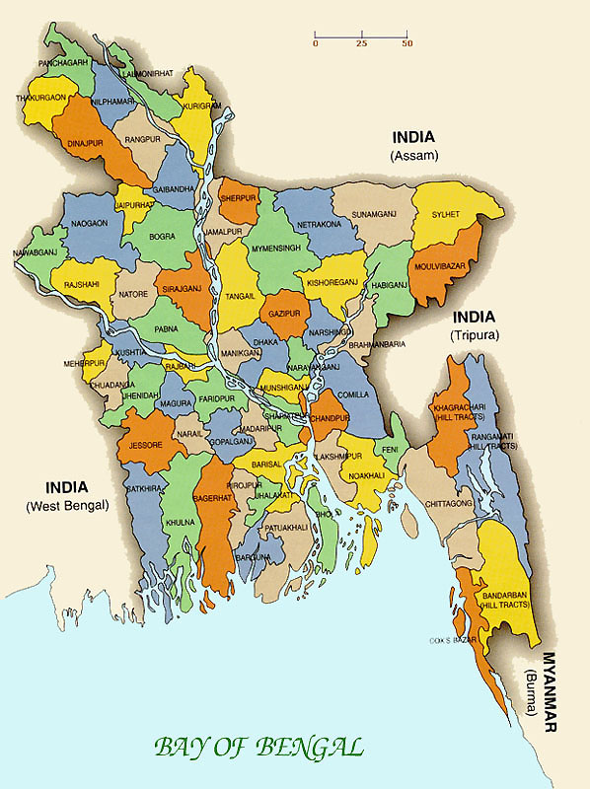

BANGLADESH DISTRICT MAP: ARROW SHOWING GROSS KAP SURVEY AREA

V.2 Agriculture Related KAP Information

V.2.1 Demographic Information on Sample Trainee Agricultural Households

Table-6: Demographic Information: Sample Agricultural Trainee
Households
Subprojects | Sample Agri Trainee Population |  |  | Land Holding (Acre) |  |  | Occupation |  |  |  | Income/month/'000 Tk
 | M | F | Total | <1 | 1 to 5 | >5 | Farm | Fish | Busi | Others | <10 | 10 to 50 | >50
Gabua Fultala | 20 | 10 | 30 | 3 | 27 | 0 | 18 | 0 | 0 | 11 | 11 | 11 | 0
Sonbunia | 20 | 10 | 30 | 1 | 29 | 0 | 19 | 0 | 0 | 11 | 23 | 7 | 0
Dehergoti | 18 | 12 | 30 | 18 | 11 | 1 | 9 | 0 | 1 | 20 | 6 | 9 | 1
Losnabad Falaghar | 20 | 10 | 30 | 18 | 12 | 0 | 9 | 0 | 8 | 12 | 14 | 12 | 0
Deulkathi-Binnapara* | 18 | 12 | 30 | 12 | 18 | 0 | 9 | 0 | 7 | 15 | 18 | 9 | 0
Sarengal* | 10 | 20 | 30 | 6 | 24 | 0 | 5 | 0 | 1 | 24 | 13 | 3 | 0
Adabaria | 15 | 15 | 30 | 12 | 17 | 1 | 12 | 0 | 1 | 18 | 6 | 11 | 0
Hetalia-Ballavpur | 18 | 12 | 30 | 14 | 14 | 2 | 14 | 0 | 1 | 15 | 14 | 10 | 0
Sapleza | 17 | 13 | 30 | 14 | 16 | 0 | 16 | 0 | 1 | 13 | 18 | 12 | 0
TOTAL SAMPLE (AGRI) | 156 | 114 | 270 | 98 | 168 | 4 | 111 | 0 | 20 | 139 | 123 | 84 | 1

Source: KAP Survey LGED, Feb 2016
- Number of trainee households in these two subprojects in Jhalokathi district was not sufficient to cover the smaple size requirement (30 HH each). Therefore, required number was compensated from two other subprojects (Sachillapur and Haripasha-Pironda) of the same district.

Trainee population has 42% female and 56% male samples, satisfying the gender dimension of the survey. Income of a good number of female trainees is reported nil and, therefore, the income earning trainee number is less (208) than the total 270 sample size. About 59% earners fall below BDT 10,000/ month and 40% earners belong to medium income group. Since fishing occupation is separately surveyed, the occupation shows zero value in this table. Other occupations include: miscellaneous income generating activities of women and men. In total, 11 modules have been delivered to the trainees (Appendix-8).

A simple observation follows this demographic data spread: agricultural training program did not select trainees from agricultural households alone. Other occupations (non-agricultural services like teaching, house-keeping, wage labor, motor driving and so on) account for 51% of total sample households while core agricultural occupation account for 41% and business account for 8% of total sample trainee households surveyed.

A number of mostly recent office orders (dated, 13/09/15, 24/11/15, 02/12/15, 06/01/16, 09/02/16 etc.) regarding selection of trainees in agricultural training programs (e.g. for agricultural production planning, need-based farm water management, land-use planning and mapping, sustainable production, ICM, seed production, processing and preservation etc.) has been issued from PMO from time to time. Selection criteria have been found to be realistic and operable, but actual selection on the ground faces a vicious circle of "aversion to new recruitment-quick listing -repetition". This requires strict follow-up from the management.

V.2.2 Training Frequency and Venue Environment

Agricultural training has been imparted during 2012 - 2015 to a good number of the nine WMCA- members. In all, 421 events have taken place out of which there was, however, unequal distribution of training events among subprojects. Adabaria and Sonbunia subprojects topped the list of training in terms of number attended while other subprojects lagged, resulting in relatively lower performance, as may be observed later in this report. Following Table shows the distribution and a graph is presented next to show the difference in distribution of training events Vertical axis measures the number of training vents attended per sample WMCA. The list of agricultural training modules used so far have been given in Appendix-8.

Table-7: Total Training Received by Sample Trainee Households per Sample Subproject
Subprojects | # Training Received Per Subproject (2013-2015)
Gabua Fultala SP | 58
Sonbunia SP | 60
Dehergoti SP | 48
Losnabad Falaghar SP | 48
Deulkathi-Binnapara SP | 30
Sarengal SP | 30
Adabaria SP | 74
Hetalia-Ballavpur SP | 39
Sapleza SP | 34
 | 421

Source: KAP Survey, LGED, Feb 2016

Figure-1: Training Received Per Subproject

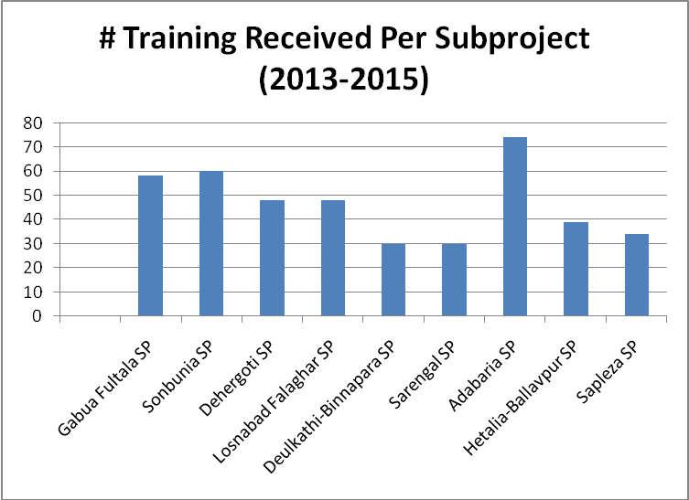

Source: KAP Survey, LGED, Feb 2016

V.2.3 New Knowledge Learnt, Applied and Effect

The project has been offering opportunities for farmers to learn about farming for higher yields and income either by adopting new crops or by economizing crop production costs through new technology. The situation has been captured from the survey. Seed processing, production and preservation, low water use technology and integrated pest management are the three components of knowledge received by the trainees at different venues during 2013-2015. The practices of some of this knowledge were also visible in the field (see photos in the Appendicese).

New knowledge (horizontal axis) and number of trainees (vertical axis) are presented in the following figure:

Figure-2 : New Knowledge and Number Trained

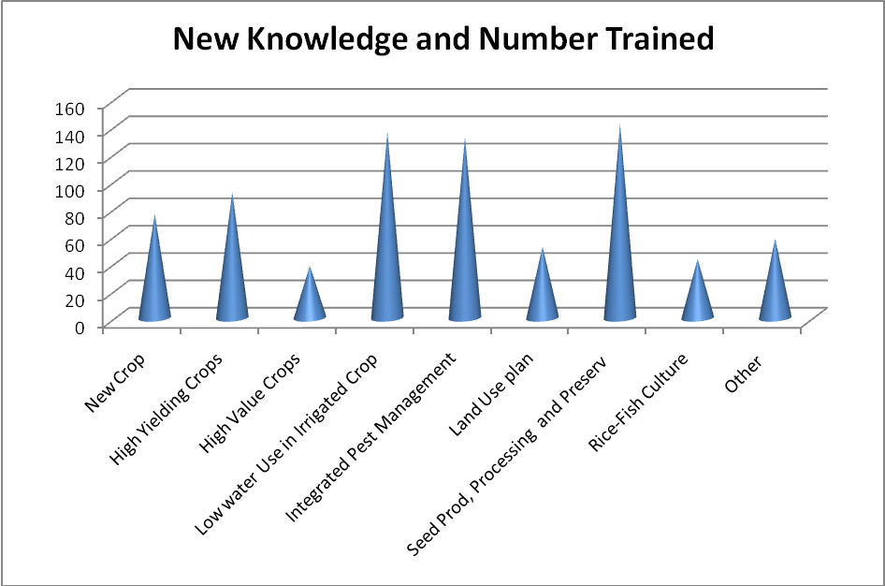

Source: KAP Survey, LGED, Feb 2016

But the variation between the number of subproject trainees is remarkable from the following figure. Hetalia-Ballavpur, Sonbunia and Gabua Fultala have got relatively more than hundred trained in different subjects, the rest have remained within a limit of 70's. The selection of trainees perhaps required to be rationalized and number equitably distributed.

Following figure represents the above description and shows the variation among the

Subprojects:

Figure-3: Trainee Number per Subproject

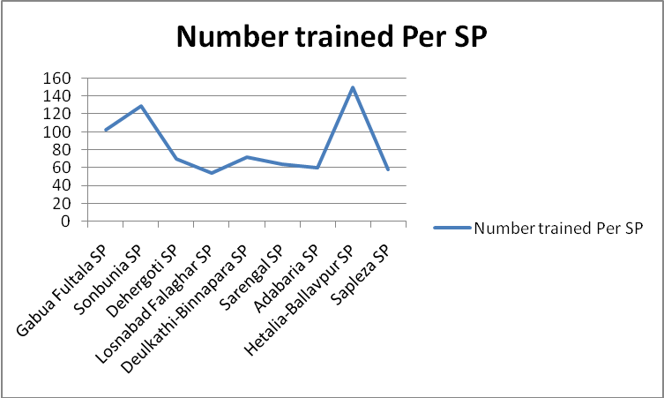

Source: KAP Survey, LGED, Feb 2016

The figure above gives the impression that 6 subprojects (Dehergoti, Losnabad, Deulkathi, Sarengal, Adabaria and Sapleza) got the least attention for training compared to Hetalia-Ballavpur situation.

V.2.4 "Field-Day" Participation Profile

The survey found almost all trainees attended "Field-day" program in all the 9 sample subprojects surveyed. Only deviation has been in Sapleza and Losnabad subprojects where some trainees did not attend the Day.

Figure-4 : ‘Field Day’ Participation Profile

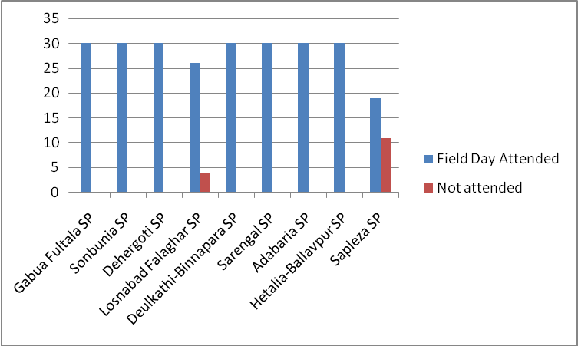

Source: KAP Survey, LGED, Feb 2016

Materials used by the resource persons during Field Day have been mentioned by the respondents in the following lines:

Figure-5 : Training Materials used in Field day

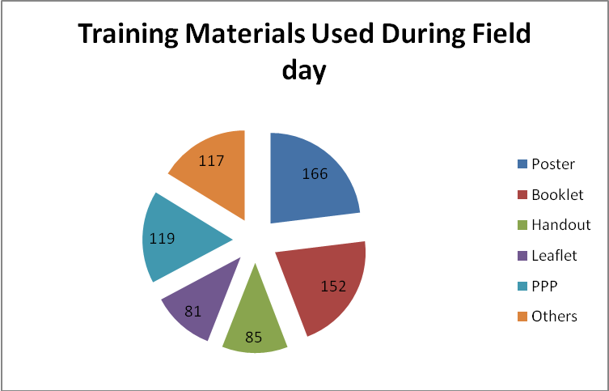

Source: KAP Survey, LGED, Feb 2016

Most used materials are: posters and booklets while other materials are PPP, leaflet and handouts. Other reference materials include pictorials, case studies and best practice examples.

V.2.5Knowledge of difference between "Demonstration" and "Normal Farm"

The said uncoordinated selection of trainees has some impacts on knowledge. For example, some trainees do not understand demonstration farm and non-demonstration farm. Survey has the following result:

Figure-6: Knowledge about Difference between Demo vs. Normal Farm

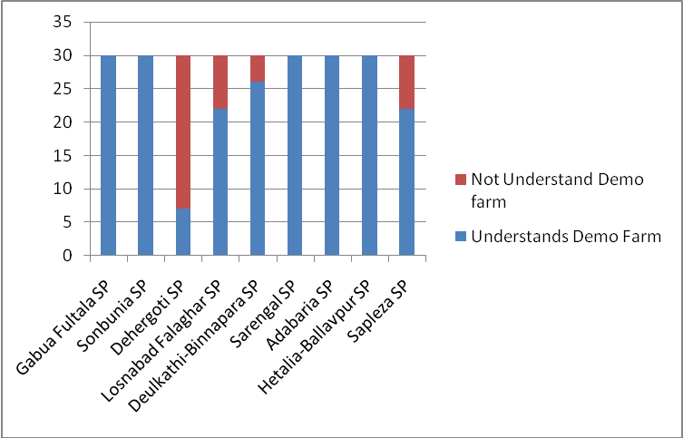

Source: KAP Survey, LGED, Feb 2016

At least 43 trainees do not understand the difference which needs to be addressed.

V.2.6 Knowledge, Attitude and Practice of Crop Planning

Knowledge, attitude and practice of crop planning have been captured through the survey on 269 respondents of different subprojects. The result is encouraging, considering the number who had prepared a crop plan for his/her own farm (169 agri HHs). But the number of those who had not prepared any plan is also large i.e. 100 trainees. The subprojects lagging in this respect also had low trainee number (see section IV.2.3 above).

Figure-7 : Knowledge and Practice of Crop Planning and Use

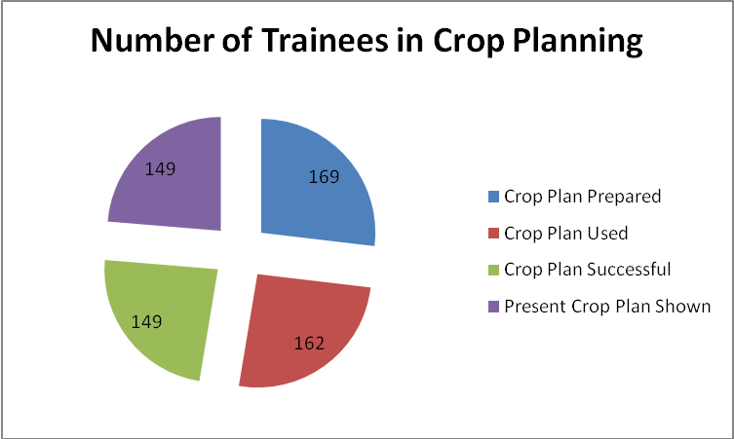

Source: KAP Survey, LGED, Feb 2016

V.2.7 Reported Effect of Training on Income

Multiple responses demonstrate that income increased for most of the respondents due to training. Yield increase, improved product quality, fair price and less crop loss constitute the important reasons for income increase while other reasons include improved culture and infrastructural facilities like irrigation water and drainage. The situation is represented by the following diagram:

Figure-8 : Respondents' Reason for Increased Income

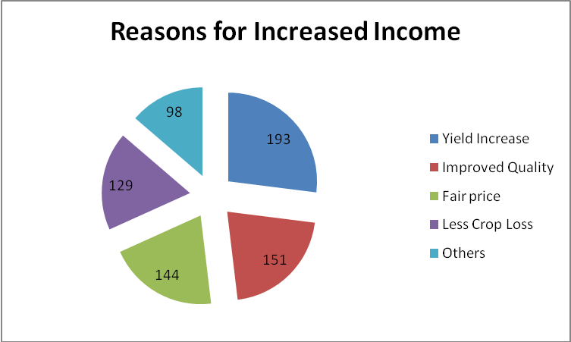

Source: KAP Survey, LGED, Feb 2016

V.2.8 Allied ( IGA related additional) Training Information

Questions were asked as to whether other allied training had been received by the respondents. Answers have been very positive and topics have been stated as follows. Multiple responses have been accepted.

Figure-9 :Number of Trainees on Allied Training Topics

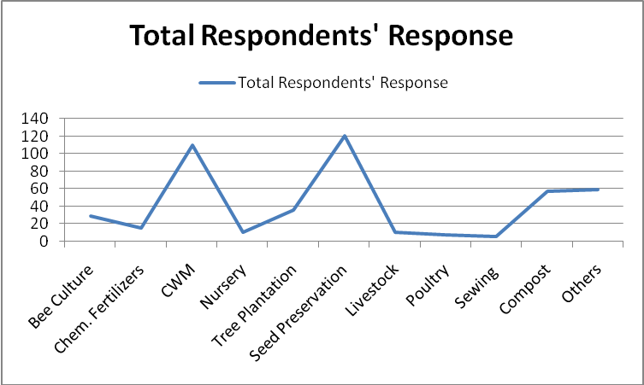

Source: KAP Survey, LGED, Feb 2016

The figure shows that crop water management (CWM) and seed preservation training has mostly and other allied trainings have generally elevated participants' knowledge.

V.2.9 Knowledge and Practice of Homestead cropping

The survey shows that the practice of homestead crops production attains a remarkable achievement. As many as 263 trainees (out of 270 sample households) received training on such crops and 239 trainees earned income out of crops practiced in homestead area. Most of female trainees have gained from the training.

Following is the graphic presentation of the fact:

Figure-10: Percent of Trainees’ Homestead Crop Practice

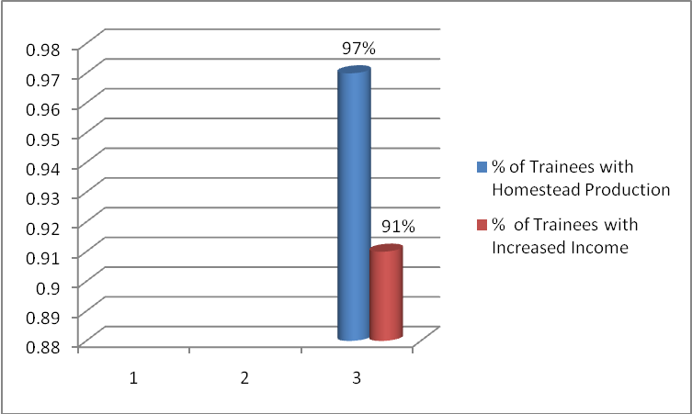

Source: KAP Survey, LGED, Feb 2016

When asked, how their income increased, at least six reasons have been expressed. Better land management, profitable crop production and new seed variety were the mostly answered reasons. Lower production cost, IPM and others (crop damage saving, safe harvest and fair price) were also the reasons of such increase.

Following diagram represents the situation. Numbers in vertical axis indicates the number of trainees reporting the means of income increase as measured along horizontal axis.

Figure-11 :Income increasing factors through Homestead cropping

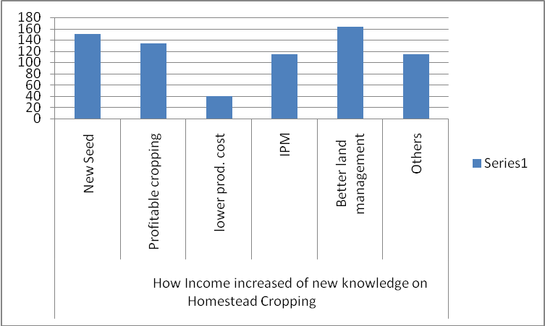

Source: KAP Survey, LGED, Feb 2016

V.2.10 Practice of Evaluating Agricultural Trainers

The survey enumerated the trainees who evaluated the trainers and who not. The picture shows 83% agreeing that they evaluated the trainers and the rest (17%) did not evaluate trainers in any form. The following graph gives the impression:

Figure-12 : Trainers Evaluating Practice

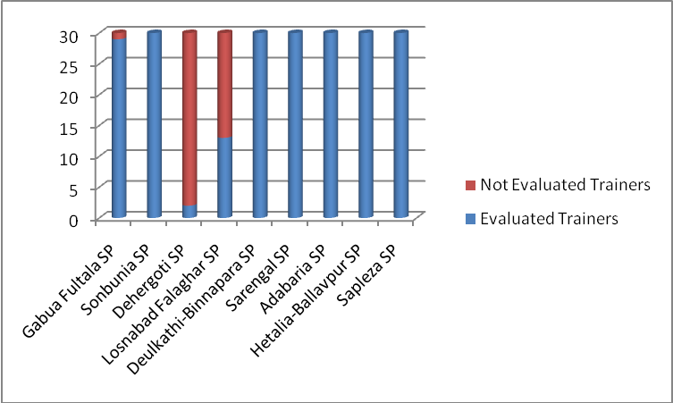

Source: KAP Survey, LGED, Feb 2016

Most of the trainees from Dehergati and Losnabad subprojects did not evaluate trainers.

The mode of evaluation was also captured from the survey as to how they evaluated their trainers : individually in the class, in prescribed form and jointly in voice vote. None used prescribed form but most of trainees evaluated individually or in joint voice. The situation is in following graph:

Figure-13 :Trainer Evaluation Modality

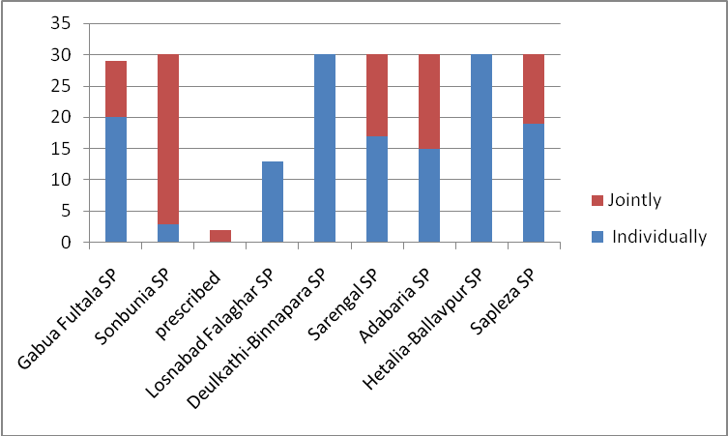

Source: KAP Survey, LGED, Feb 2016

V.2.11 Need for Additional Training

Questions were asked as to what other topics of training they felt required for their livelihoods improvement and sustainability. The responses were encouraging. Females were with sewing exclusively and both the genders opted for more 10 other trades for their skill development, financial income and self-dependency. The options have been reflected in the following graph. Poultry, compost, irrigation management, seed production and fruits were rated high in descending order of demand.

Figure-14 :Topics of Additional Training Needed

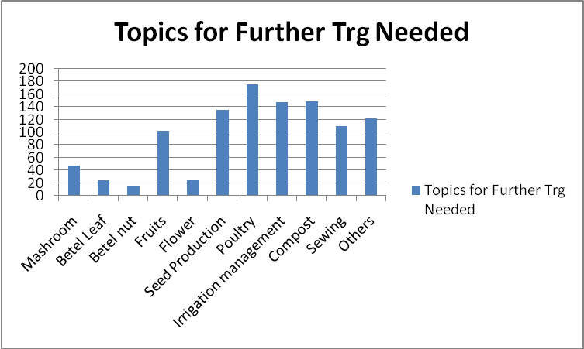

Source: KAP Survey, LGED, Feb 2016

V.3 Fisheries Related KAP Information

V.3.1 Demographic Information on Sample Trainee Fisheries Households

Four subprojects were selected for survey on the basis of fisheries potential and geographic distribution in the universe. Eighty fishery trainee households were interviewed with 20 HHs in each of the selected 4 subproject (see Inception Report, Feb 10, 2016). More than 20% were picked from women trainees on an average while in Gabua-Fultala SP, the proportion is 50:50. Adabaria scores the least having only 10% female trainees in fisheries.

Table-8: Demographic Information: Sample Fisheries Trainee Households
Subprojects | #Sample Fish Trainee Population |  |  | Land Holding (Acre) |  |  | Occupation |  |  |  | Income/month/ '000 Tk
 | M | F | Total | <1 | 1 to 5 | >5 | Farm | Fish | Busi | Others | <10 | 10 to 50 | >50
Gabua-Fultola SP | 10 | 10 | 20 | 3 | 17 | 0 | 10 | 0 | 0 | 10 | 15 | 4 | 0
Losnabad-Falaghar SP | 15 | 5 | 20 | 7 | 13 | 0 | 7 | 2 | 2 | 9 | 10 | 6 | 0
Sarengol SP | 16 | 4 | 20 | 4 | 13 | 3 | 2 | 10 | 1 | 7 | 13 | 5 | 0
Adabaria SP | 18 | 2 | 20 | 4 | 15 | 1 | 12 | 2 | 1 | 5 | 5 | 14 | 0
TOTAL SAMPLE | 59 | 21 | 80 | 18 | 58 | 4 | 31 | 14 | 4 | 31 | 43 | 29 | 0

Source: KAP Survey, LGED, 2016

Looked at from occupational distribution, trainees with fishery background count only around 17% of total trainees while trainees with occupation like business and others (petty trades, driving, wage labor, van puller, students, housekeeping etc) count as much as about 44% and those with farming background count 39%. Here is a management issue with regard to trainee selection . Data on land size distribution of trainees also support this fact that farmer- trainees (39%) and business- trainees (58%) were selected. As for income level, 90% of respondents have reported their income levels and 10% with no income because they were female trainees or with no income yet. Income distribution shows 60% of responding population in low and 40% in medium income group.

V.3.2 Training Frequency and Venue Environment

Fishery Training Frequency

Fisheries trainings have been imparted from the project since 2012 and it is still ongoing. A stock of how many courses have been offered to KAP survey sample subprojects in Barisal Division has been taken in the following lines till 2015. Training was provided by local DoF specialists and LGED Fisheries Specialist while training venues were: (i) Fish Seed MF, Baghata, Narsingdi and (ii) YTC, Savar. On-site Fisheries training was held only once at Gabua-Fultala WMCA. Gabua-Fultala WMCA members were taken 7 times during 2012-2014 for training under different modules while Adabaria and Sarengal were taken 4 times each and Losnabad only once.

 | Table-9:Fisheries Training Modules Delivered (2012-2015) in Sample 4 Subprojects
l. No. | Training Module Name | SP Name | Venue | Year
1 | Fish Production Tecnology(Fingerling) | Gabua Fultala | Fish Seed MF,Narsingdi | 2012
 |  | Losnabad Falaghar | Fish Seed MF,Narsingdi | 2014
 |  | Sarengal | Fish Seed MF,Narsingdi | 2014
 |  | Adabaria | Fish Seed MF,Narsingdi | 2013
2 | Fish Production Tecnology(Telapia) | Gabua Fultala | FSM,Farm Narsingdi | 2012
 |  | Sarengal | FSM,Farm Narsingdi | 2015
 |  | Adabaria | FSM,Farm Narsingdi | 2013
3 | Fish Production Tecnology(Pond Fish) | Gabua Fultala | FSM,Farm Narsingdi | 2012
 |  | Sarengal | FSM,Farm Narsingdi | 2014
 |  | Adabaria | FSM,Farm Narsingdi | 2013
4 | Fisheries Program Management Course | Gabua Fultala | YTC,Savar,Dhaka | 2012
 |  | Sarengal | YTC,Savar,Dhaka | 2014
 |  | Adabaria | YTC,Savar,Dhaka | 2013
5 | Rice-Fish Culture | Gabua Fultala | FSM,Farm Narsingdi | 2012
6 | On-site Fisheries Training | Gabua Fultala | WMCA | 2013
7 | Trng. In Fisheries extension support for fish Prod | Gabua Fultala | FSM,Farm Narsingdi | 2013

Source: KAP Survey, LGED, Feb 2016

RDA experts, Bogra, also observed that they offered training on Rice-Fish culture in their own farm within the vicinity of RDA.

Based on the above events, trainees from different WMCAs were invited to training venues (see below). Eighty such trainees attended from the 4 sample subprojects 129 times, meaning a good number of trainees were called more than once which is possible for different modules. Selections have been from among members of respective WMCAs. Occupational distribution of trainees (see demographic profile of trainees above) give a wrong signal that selection was not appropriate for most cases. The principles of selection have recently been well-defined in an Office Order (vide PD/PSSWRSP Memo No. 471 dt. 01.02.2016). However, selection is expected to be rational if the principles laid out in the said memo. is strictly followed.

The Fishery Training Venues

Evaluation of training venue was made through a question "Was the venue good for you?". The answers varied according to respondents' experience. Forty percent viewed the venue (Narsingdi FSM Farm) as "good" and the rest 60% rated it "not good". The venue was visited by the consultant on 13.04.2016 and attended one ongoing session in the class room. The DFO, Narsingdi informed that the Farm and the Training center are being used intensively by the Government Departments like Youth Development, Ansar VDP, Department of Agriculture, Department of Fisheries, Mymensingh Agricultural University, Jahangirnagar University, Dhaka University and different colleges of Bangladesh.

The reason why the Center has been rated "not good" was elicited from the management of the Farm while visiting the residential accommodation and facilities exposed for the incoming trainees from different subprojects of PSSWRSP. Compared to other training centers like RDA, BARD, BCA etc. (all visited by consultant earlier) the rooms and beds and other provisions/facilities were found to be of ordinary category. Particularly, the stay of women participants was reported to be uncomfortable (as learnt from the attending women participants). Centering on the good will of the Farm as a leading and fast growing Fishery training Farm, Government is also developing its infrastructures, however, in an incremental way.

All attending participants appreciated the quality of training and trainer-trainee relationship in the Farm. The consultant came across a circular from the Project dt. 01/02/2016 declaring that the trainees would have to put on "napkin/lungi' as may be suitable while on training in the Farm and would have to sleep on hatchery platform at night. These conditions, however, predispose the potential participants for adapting themselves to the ordinary staying condition of the training center.

Majority of respondents agreed that the trainers used books, posters and booklets, pictures etc. while delivering lectures. The situation is reflected in the following pie chart:

Figure-15 :Number of Trainees Mentioning Materials used by Trainers

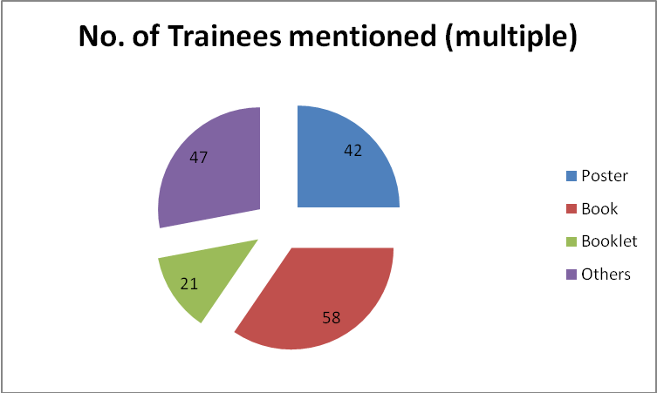

Source: KAP Survey, LGED, Feb 2016

V.3.3 New knowledge Learnt, Applied

Questions were asked during survey about components of new knowledge learnt from Fisheries trainings (particularly, Nursery preparation, Pond preparation, Fingerlings production and Tilapia culture) . Out of 80 respondents, 75 attended the trainings. Compared with success in application of such knowledge, the situation turns up as follows:

Figure-16 : New Knowledge and Practice Levels of Trainees

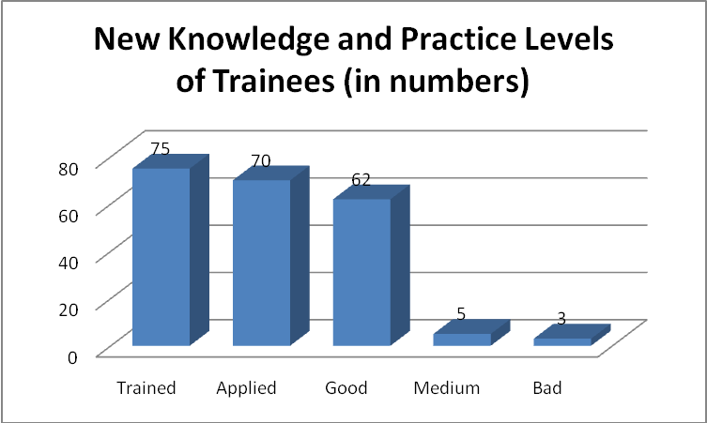

Source: KAP Survey, LGED, Feb 2016

V.3.4 Knowledge of New Fish Culture and Practice

Questions were asked about knowledge and practice of new fish species culture during household survey of trainees. Responses have been encouraging. While trainees were 80 in number, 64 (80%) have been in regular fish culture with adequate knowledge. Seven varieties of fish crops are learnt to be in practice (carp, shrimp, pangas, rui, sarputi, koi and magur) while other species are also being practiced.

Figure-17 : Different Fish Species Culture Practicing

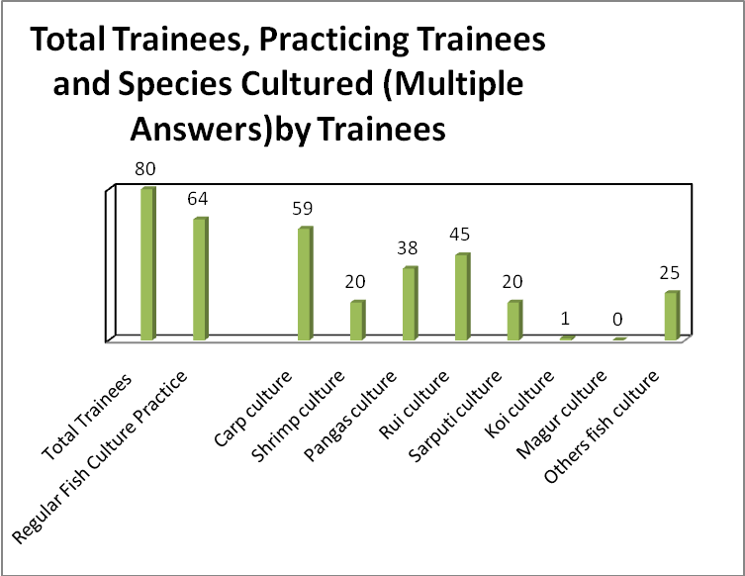

Source: KAP Survey, LGED, Feb 2016

V.3.5 Knowledge of avoiding Fish Health Risk

Fish health has been of immense importance from resource economics point of view. Knowledge imparted through Project training program has been successful, as per the data collected through KAP survey. Following table gives the summary of findings on trainees' knowledge and practical measures taken to manage fish health hazards.

Table-10: Knowledge of Trainees about Fish Health Risk Management
Subprojects | Knowledge of Trainees about Fish Health Risks Management (in %)
Subprojects | Maintain Water Quality | Clear Weeds | Pond Drying in 2/3 years alternatively | Eliminate Predator Species | Release Healthy Fingerlings | Supply Adequate Good Food | Using Lime, organic matters etc
Gabua-Foltola SP | 100 | 0 | 100 | 100 | 100 | 10 | 85
Losnabad-Falaghar SP | 60 | 40 | 100 | 100 | 100 | 0 | 35
Sarengol SP | 100 | 0 | 100 | 100 | 100 | 10 | 100
Adabaria SP | 100 | 0 | 100 | 100 | 100 | 100 | 100

Source: KAP Survey, LGED, Feb 2016

The table above demonstrates that most of the trainees could apply measures against fish health hazard, except for remarkable low number occuring in Gabua-Fultala and Sarengal subprojects in matters of supplying good fish food only.

V.3.6 Knowledge of Fisheries Program Management and its Application

Fisheries Program Management course has been pursued by LGED for WMCA members during 2012-2014. Out of 80 respondents 49 took the training, 45 applied the knowledge in their own or others' pond and 4 have almost forgotten the content. Application is, therefore, successful by 92%.

Figure-18 : Fisheries Management Practice Levels

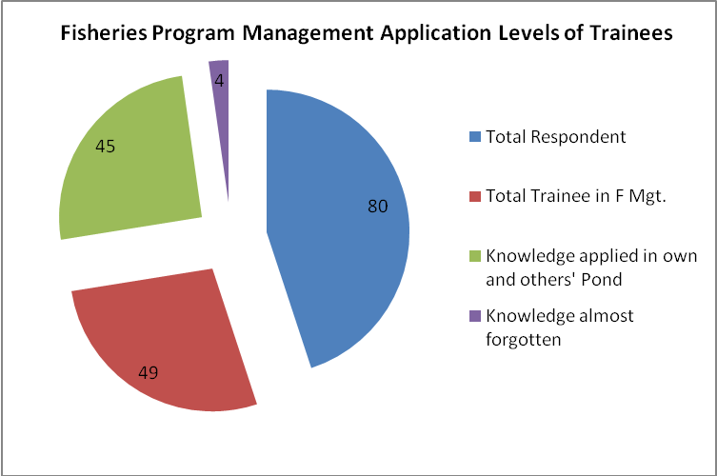

Source: KAP Survey, LGED, Feb 2016

V.3.7 Knowledge and Practice of Rice-Fish Culture

Practice of rice-fish culture has been a very popular practice now-days. PSSWRSP also

enhances this practice through training. In the 4 sample subprojects, good number of WMCA

members received this training. Result of the training has been good: 100% applied and succeeded for 1, 90% applied and succeeded for 1 and 60% applied and succeeded for 1 other subproject. The worst one also had 50% applied and 30% succeeded, as presented in the following figure.

Figure-19 : Knowledge and Practice of Rice-Fish Culture

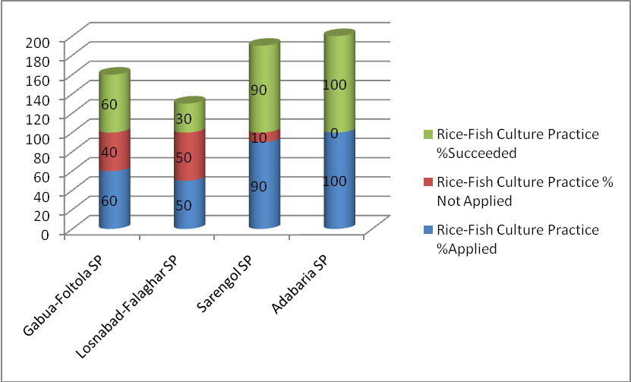

Source: KAP Survey, LGED, Feb 2016

V.3.8New Knowledge, Practice Dynamics and Increased Income

Closed ended questions were asked to collect knowledge and practice of new fish culture and increased income from such enterprises in the sample subproject fish farmers. Out of 73 respondents 59 (81%) agreed that they had knowledge, practice and resulting increased income from knowledge and skill through training. Six important causes of increase in income have been informed by number of respondents: new variety (42), high value fish (45), HYV species (22), preservation of fish fingerlings (57), measures against fish health hazard (53) and supply of good fish-feed (21). Number of respondents for each reason is presented in the following figure (number includes multiple answers).

Figure-20 : Number of Trainees Mentioning Causes of Increased Income

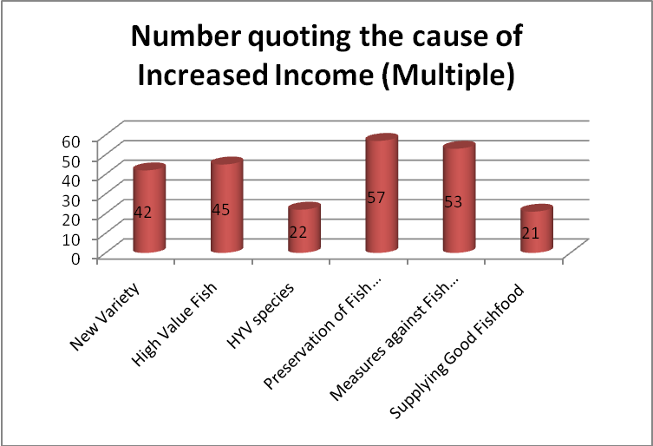

Source: KAP Survey, LGED, Feb 2016

V.3.9 Practice of Evaluating Fisheries Trainers

Questions were asked whether trainees (respondents) evaluated their trainers in respective training venues. Good number of respondents (61 out of 80, i.e. 76%) said they evaluated trainers and the remaining 19 (24%) did not evaluate. The form of evaluation was again mostly ( (67%) verbal ( singly saying good or medium or bad) and 33% evaluated in a joint voice vote in the classes. None of the respondents formally evaluated the trainers in proper forms. The situation is as in the following figure.

Figure- 21: Fisheries Trainer Evaluation Profile

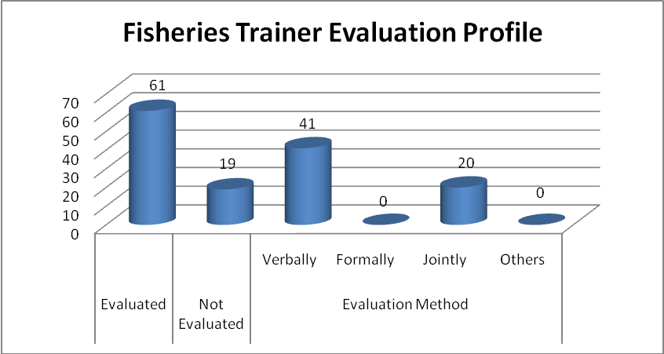

Source: KAP Survey, LGED, Feb 2016

V.3.10 Respondents' Reason for Taking Fisheries Training

Hundred percent of respondents from Gabua-Fultala and Adabari WMCAs agreed that they took part in fisheries training programs because it was financially profitable and good source of learning a new trade. Most of the respondents from Sarengal and Losnabad said that it was a good learning only. The two types of response indicate two issues:
- financial benefits promote learners' attitude to learn more to earn more only when learners have access to fields (ponds or water body) to practice the lessons learnt
- trainees without access to such ponds or water body take it a learning only and they have chances to forget the lessons with time.

Training programs, therefore, have to consider these issues while selecting trainees for fisheries modules.

V.4 Basic Cooperative Management Related KAP Information

The seven WMCAs interviewed (see table below) have responded to questions appropriate for management of WMCAs. Issues include knowledge, attitude and practices around understanding of WMCA formation and commitment to subproject sustainability requirements. KAP has been reflected through what they have expressed, how their mind-set works and what they actually perform in terms of holding meetings, keeping records and registers, operating daily business, holding AGM, attending trainings and applying knowledge acquired, applying bye-laws when needed, conducting cooperative activities according to cooperative laws and regulations etc.

Table-11: Schedule of KII with 7 Sample WMCA Bodies

Nme of Subproject
District | Date of Survey
1. Losnabad -Falaghar (SP44075) | Barisal | 11.03.16
2. Sarengal (SP44104) | Jhalokati | 12.03.16
3. Hetalia-Ballavpur(SP44143) | Patuakhali | 13.03.16
4. Gabua-Fultala(SP42016) | Barguna | 13.03.16
5. Nur Ali Bururchar (SP43029) | Barguna | 14.03.16
6. Potkakhali (SP43034) | Barguna | 14.03.16
7. Sapleza (SP42022 | Pirojpur | 15.03.16

The data and information in this section have been presented for the selected 7 WMCAs which are representative of the 20 subprojects located in 5 out of 6 districts of Barisal Division. These include responses from men and women members of WMCAs together and no disaggregation has been possible as no individual question was asked.

V.4.1 Training Frequency Profile and Major training Topics (Knowledge)

Training frequency means how many times the sample WMCA members received training on different topics of basic cooperative management (BCM). In all, seven modules on basic cooperative training have been delivered (see Appendix-9). Responses are presented in graphic order for easy understanding as below. Maximum number of times WMCA members attended is from three subprojects: Nurali Burirchar, Losnabad and Sarengal.

Figure-22 : Total Training Received on BCM Per WMCA

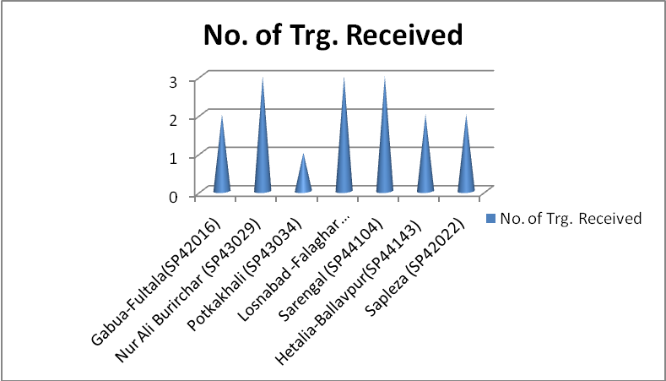

Source: LGED KAP Survey, March, 2016

If looked at from performance point of view, these three subprojects have the following status according to data collected from respective WMCAs

Table-12: Status of Performance of Selected Subprojects
Name of SP Acquiring Coop. Mgt. Knowledge | Status of Performance in selected Practices
Name of SP Acquiring Coop. Mgt. Knowledge | Bye-Law Practice | AGM Proceedings Preparation | Annual Report Preparation
1.Nurali  Burirchar | Reportedly, discussion was held in meetings but no mention in any meeting proceedings during last two years (2013-2015) | When asked for, no AGM proceedings shown during survey | Annual Report Prepared and shown during survey
2.Losnabad-Falaghar | Bye-law discussed and proceedings shown during survey | AGM proceedings shown when asked for | No Annual Report prepared or shown during survey
3.Sarengal | Discussion held but no record in any meeting proceedings during last two years (2013-2015) | AGM proceedings shown during survey | Annual Report prepared but could not show when asked for

The topics they have been trained during cooperative management are recorded in the

following graph.

Figure-23 : Number of WMCAs Receiving Various Modules of Basic Management Training

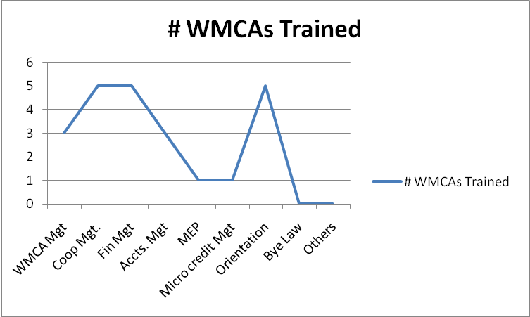

Source: LGED KAP Survey, March, 2016

Both the graphs indicate good frequency and wide coverage of topics needed for Cooperative

Management. Financial Management, WMCA Management and Orientation tops the list of total subjects taught. But the status above demonstrates (see the boxes with italics) the low impact of knowledge as such in practical workplace on the ground (see also figure in section IV.4.2).

V.4.2 Bye Law Preparation and Use Profile (Attitude and Practice)

Bye-law has been the pivot for conducting day-to-day business of WMCAs, as per cooperative law.

Each WMCA interviewed has a Bye-law, prepared mostly in close association with DOC local Inspectors and LGED functionaries. Use of this Bye-law in practice is hardly found in the records of discussions and reports. The situation is reflected by the following figure:

Figure-24 :Bye-Law Preparation and Use Profile

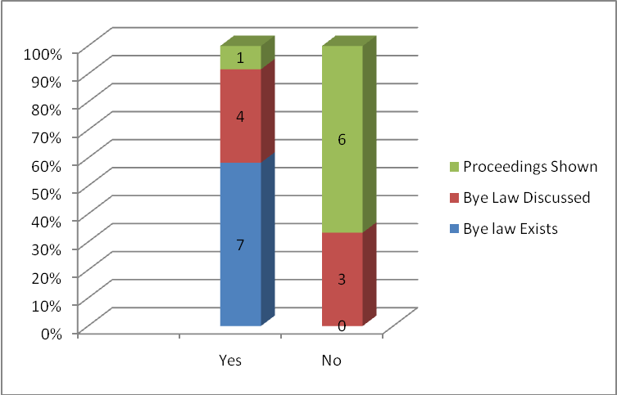

Source: KAP Survey, LGED, Feb 2016

V.4.3 WMCA Registers Regularity (Attitude and Practice)

Member Registers and MC Meeting Registers have been invariably found in all the sample WMCAs. The quality of maintaining records of discussions in Registers differ with different WMCAs. Community Assistants and Community Organizers often help in writing records. In few cases, the practice is found improved due to General Secretary's own initiatives and educational background. For example, Mr. Belayet Hossain, an ex-primary school teacher and the elected Secretary of Potkakhali WMCA writes proceedings of meetings himself and its quality is good.

V.4.4 AGM Report and Proceedings Writing Practices (Knowledge and Practice)

Annual General Meeting (AGM) is a vital event of WMCA when all members have a chance to share all information of their cooperative association. Chairman presents the global profile of financial, organizational and promotional activities in writing to the members in this meeting.

This KAP Survey shows that 6 out of 7 WMCAs reported to have presented their annual report during AGM, but only 1 WMCA (Potkakhali) could show the Report physically. Another WMCA (Losnabad - Falaghar) did not prepare any Annual Report for AGM.

WMCA executives are not aware well that this is necessary. Moreover, secretarial practices are wanting in this respect. Knowledge and attitude is inadequate. Future training courses need to ensure that Annual Report writing exercise becomes mandatory and the Reports are read out in AGM of WMCAs.

V.4.5 Sub-committee Operational Status (Attitude and Practice)

There are six subcommittees in each WMCA, namely: O&M, Microcredit/Loan, Gender, Agriculture, Fisheries and IGA. The survey shows that 4 out of 7 subcommittees did hold meetings and 6 could show subcommittee registers (see figure below). A space is there for improvement through training and monitoring. The cases of not holding meetings signal low effectiveness of training.

Figure-25 : Sub-committee Operational Status

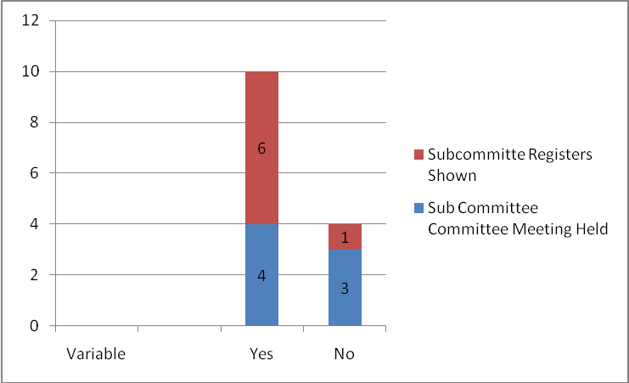

Source: KAP Survey, Feb 2016, LGED

V.4.6 Audit & Accounts Regularity (Knowledge and Attitude)

The survey found all sample WMCAs having regular accounts and audit registers with certification from Auditors of the Department of Cooperatives

During the survey and KII at Barisal Zonal Cooperative Institute, the course content and time distribution for the ongoing Accounts Management training has been reviewed. A strong observation on the inadequacy of time has been made and present 2-Day duration is proposed to be extended to 3-Day for delivering effective knowledge and skill. A specimen Module for the proposed 3-Day training course is given for consideration of the Project Management (Appendix- 10). .

V.4. Cooperative Inspector's Visit Status (Attitude)

For sustainability of WMCA activities, visit of Cooperative Inspectors to the Associations has been of immense importance. It is learnt that one Inspector has been designated exclusively for Water Cooperatives in each District. When asked how frequently the Inspector visits them, the answers are diverse as the figure indicates below:

Figure-26 : Cooperative Inspector's Visit Status

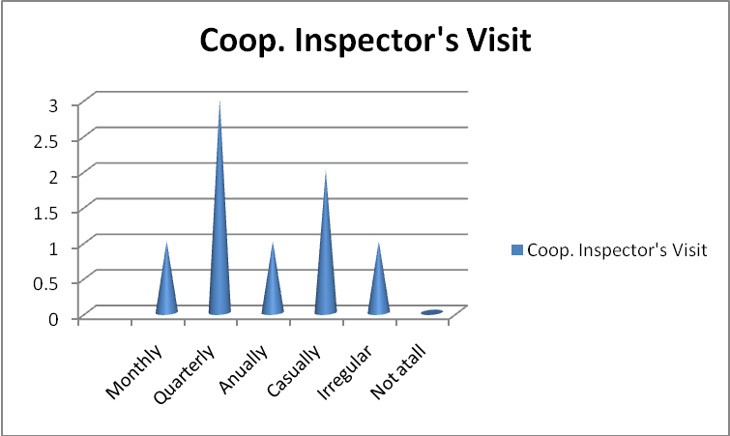

Source: KAP Survey, Feb 2016, LGED

Three WMCAs have reported Inspector's visit quarterly while two have reported casually (meaning, when needed) and 2 others have answers like irregular and annual. None, of course, has reported no visit at all. This signifies that Inspectors visits the WMCAs but its efficacy and efficiency are yet to be visible in terms of better performance of WMCAs.

V.4.8 Annual Report Preparation and Practice (Knowledge and Practice)

Annual Report preparation is a major exercise for each Cooperative Association according to Cooperative law. This survey reveals that Annual report preparation has been taught for trainees from 6 out of 7 sample WMCAs, but only 1 WMCA could show it physically when asked for. Therefore, a practice- gap is there although knowledge has been imparted to WMCA executives through training.

Figure-27 : Annual Report Preparation Knowledge and Practice Status

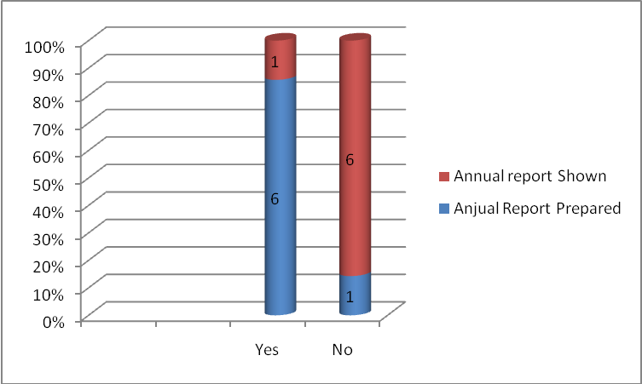

Source: KAP Survey, Feb 2016, LGED

V.4.9 Perception about Importance of Coop. Mgt. Training (Attitude)

Cooperative Management has been the prime subject for trainees of all WMCAs. All respondents have positively responded to the question of its importance for their day-to-day WMCA activities. But the answers vary according to the respondents' attitude to the training and their own assessment of how useful the training is in their jobs on hand. The answers are reflected in the following figure:

Figure-28 : Perception about Importance of Coop. Mgt. Training

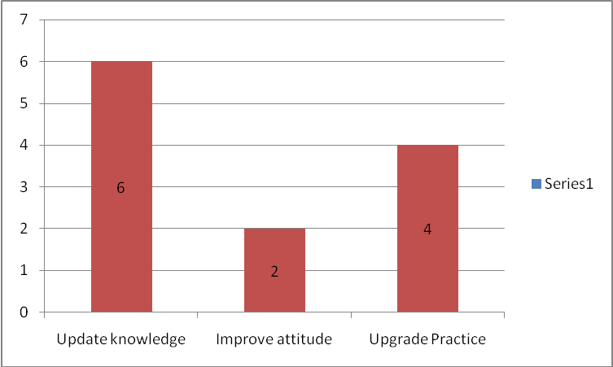

Source: KSP Survey, LGED, Feb 2016

6 out of 7 interviewed WMCAs expressed that the cooperative management training updated

Their knowledge, 2 only agreed that it improved attitude to cooperative principles and 4 out

of 7 thought that it upgraded their practices in WMCA management on the ground.

V.4.10 Training Materials Use and Efficiency

Training materials used by the trainers in classroom situation have been assessed through responses of the trainees. All the respondents have invariably said that Cooperative Management Handbook was used, 4 WMCAs said it was audio-visual instrument and 3 WMCAs said that White Board was used by the trainers. Overall indication is that the trainers are equipped with at least minimum training instruments.But the quality of these have to be updated .

V.4.11 Attitude towards Special Knowledge Need

Following is the detailed list of choices of number of WMCAs (out of 7 WMCAs surveyed) for 7 kinds of special knowledge:

Figure-29 : Number of WMCAs Demanding Special Knowledge (Multiple)

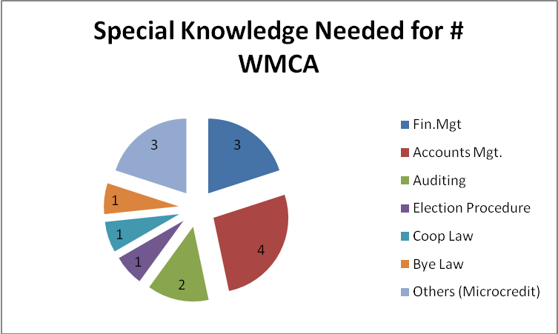

Source: KAP Survey, LGED, Feb 2016

Most wanted knowledge is Accounts management and the second most are: Financial management and Microcredit operations . Auditing is the third most and knowledge of Election procedure, Bye Law and Cooperative Law are needed by the lowest number of WMCAs.

V.4.12 Attitude towards Member Education Program

Member Education Program (MEP) has been continuing since last year (2015). Its need has not yet been understood well by WMCA office bearers as revealed from responses from them. Closed ended questions were asked and only two WMCSAs (Sarengal and Sapleza) have admitted the benefit of the program. Perceived benefits of MEP have been expressed to be improved attitude and sustainability of WMCAs.

VI. CONTROL AREA DATA AND INFORMATION

VI.I Control Area Respondent Information on KAP of Agriculture

In all 30 agricultural households have been surveyed. Villages included in control area have

been listed in Appendix-6. The demographic profile of control area households are given

below:

VI.1.1 Demographic Profile

Table-13: Control Area Demographic Profile of Agricultural Trainee Households
Control Area Neighboring to Subprojects | Sample Agri Trainee/non-Trainee Population |  |  | Land Holding (Acre) |  |  | Occupation |  |  |  | Income/month/'000 Tk
 | M | F | Total | <1 | 1 to 5 | >5 | Farm | Fish | Busi | Others | <10 | 10 to 50 | >50
Gabua-Fultala | 7 | 3 | 10 | 0 | 10 | 0 | 2 | 0 | 3 | 5 | 1 | 5 | 0
Sarengal | 9 | 1 | 10 | 7 | 3 | 0 | 3 | 0 | 2 | 5 | 3 | 7 | 0
Losnabad | 10 | 0 | 10 | 7 | 3 | 0 | 10 | 0 | 0 | 0 | 10 | 0 | 0
TOTAL CONTROL | 26 | 4 | 30 | 14 | 16 | 0 | 15 | 0 | 5 | 10 | 14 | 12 | 0

Source: KAP Survey, LGED, Feb 2016

VI.1.2 Training Information

Out of 30 respondents, 8 agreed that they received training from BADC, BRDB, International NGO and BD -NGOs. BRAC has been the major name of training provider, coming out from responses.

VI.1.3 HYV Practices

Mainly High Yielding Crop Varieties are cultivated in the control area based on the knowledge received from training from sources other than project. This shows that control population also know the HYV cropping technology and practices mainly as a spill over benefit.

But when asked how they could practice the crops on fields, they replied in the following ways (multiple answers, meaning learnt from more than one source, make the total more than 30):

- Total respondents : 30
- Learnt from LGED subproject farmers : 18
- Learnt from trained relatives : 15
- Learnt from self initiatives : 11

VI.1.4 Benefits of Training

Control area population also get benefits from training from sources like BADC, BRDB and NGOs (see section (VI.1.2 above). Major three dimensions of benefits have been open to them: high cropping intensity, comparative (before and after training situation) low production cost and HYV crops. The situation is captured in the following figure:

Figure-30 : Benefits of Training in Control Area

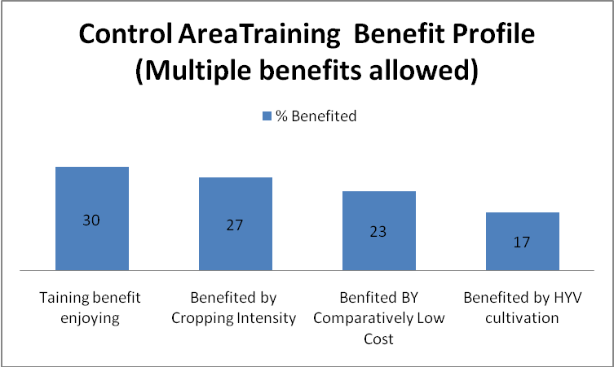

The benefits, however, have been of conjunctive (control and project together) nature as can be understood from section VI.1.3 above where 60% respondents have agreed that they learnt the cropping practices from neighboring LGED subproject farmers.

VI.1.5 Knowledge and Practice of Annual Crop Planning

Annual crop plan preparation has been known to control area population also, as learnt from the survey. Plan does not imply a sophisticated typical professional crop plan on papers as such, but a scientific statement of where to plan which crop in what time of the year, in view of the land suitability and elevation. In that context, control area response is in the following figure:

Figure-31 : Control Area Crop Plan Preparation

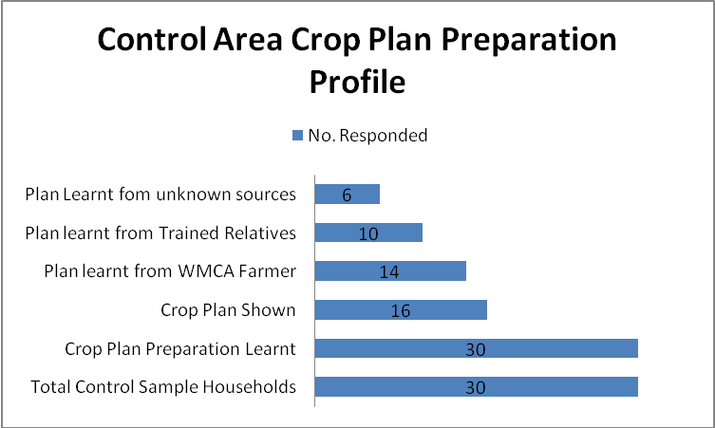

VI.1.6 Knowledge and Practice of Homestead Crop

Control households know the homestead crop culture from different sources as described in section above. The practice levels are captured from the survey in the following lines:

Figure-32 : Control Area Homestead Crop Growing practices

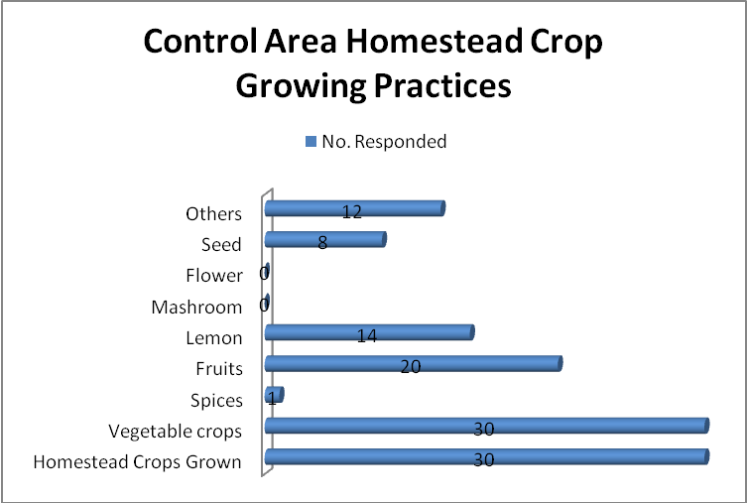

VI.1.7 Control Area Attitude to Project KAP in agriculture

Specific question was asked to the control area farmer households about the importance of training and difference of their knowledge from the knowledge of WMCA farmers. Answers were very direct and clear. Hundred percent control farmers responded positively about the importance of training and about the higher levels of KAP in their neighbor WMCA farming community.

VI.1.8 Comparison between Control and Project Area Agricultural KAP

Table-14: % of People with Knowledge and Practice in Project and Control Areas
Major KAP Variables | Knowledge and Practice of Project Trainees (in % of population) | Knowledge and Practice levels of Control Population (in % of population)
HYV Production | 100 | 100
Annual Crop Plan Preparation Known | 100 | 63
Annual Crop Plan shown | 53 | 88*
Homestead crops Grown | 100 | 97
Seed grown | 27 | 35**
Other crops grown | 40 | 50**

*Tabulated data shows this result, but this is an outcome of misunderstanding between enumerator and respondents. Here "shown" does not imply actual showing of written plan, it is a statement explaining that they follow a plan unlike a scientific plan followed by Project trainees.

**These figures show higher numbers than those for subproject area. But quality and quantity of seed and other crops are learnt to have been much less than those in subproject area.

Above comparison apparently gives a mixed impression about the effect of training in project area. Population without training (control population) is practicing almost comparably with project population. But from production point of comparison, project outputs are learnt to be more than control area outputs in all respects. As explained elsewhere, practices have changed through transmission of knowledge and practices from PSSWRSP to its neighboring area outside subprojects (control area). In ultimate terms, project outputs (quantity and quality) are far more and better than those of control area because of direct training impact and total knowledge among project trainees rather than partial and low demonstration effect in control area farmers.

VI.2 Control Area Respondent Information on KAP of Fisheries

VI.2.1 Demographic Profile

Population with fishery occupation or interest is less than farming population. In areas neighboring to PSSWRSP subprojects (control area) population with fisheries background has been found in 4 villages (see Appendix-7). Twenty HHs have been surveyed where 10 HHs are fishing ones and the remaining HHs are farmers and others. Few HHs belong to two other neighboring subprojects (Gourbunia and Deshantarkathi) but the HHs surveyed are not trainee HHs.

The demographic information of control area fishery HHs is presented below:

Table-15: Control Area Demographic Profile of Fisheries Trainee Households
Control Area Neighboring to Subprojects | Sample Fisheries Trainee/non-Trainee Population |  |  | Land Holding (Acre) |  |  | Occupation |  |  |  | Income/month/'000 Tk
 | M | F | Total | <1 | 1 to 5 | >5 | Farm | Fish | Busi | Others | <10 | 10 to 50 | >50
Gabua-Fultala | 7 | 3 | 10 | 7 | 3 | 0 | 7 | 0 | 0 | 3 | 8 | 2 | 0
Sarengal | 10 | 0 | 10 | 0 | 8 | 2 | 0 | 10 | 0 | 0 | 6 | 4 | 0
TOTAL CONTROL | 17 | 3 | 20 | 7 | 11 | 2 | 7 | 10 | 0 | 3 | 14 | 6 | 0

Source: KAP Survey, LGED, Feb 2016

VI.2.2 Fish Culture profile

Fish culture presumes owning or having water-body of any kind under any holding status. Among the 20 respondents in control area, pond-owning HHs are 55% (see figure below).

Figure-33 : Control Area Pond Owning Status

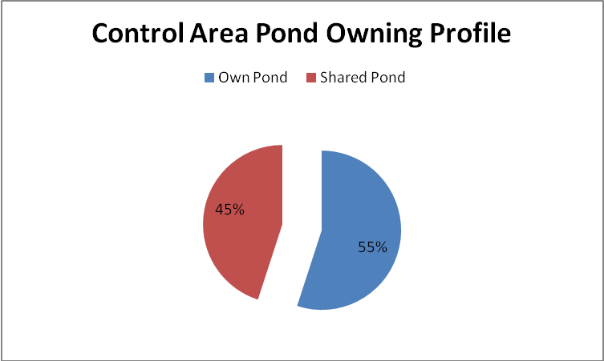

Source: KAP Survey, LGED, Feb 2016

Fish cultural profile is reasonable where 90% have carp, 80% have Pangas and 65% have Rui varieties. Others are Sarputi, Shrimp and Koi.

Figure-34 : Fish Culture Profile

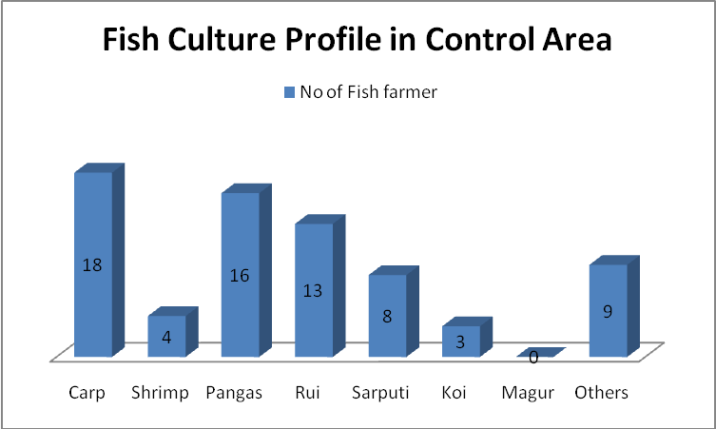

Source: KAP Survey, LGED, Feb 2016

VI.2.3 Fisheries Knowledge, Attitude and Practice

Fishermen (50%) received training from DoF, INGO and DNGOs. Main training subjects were production of hybrid fish, pond preparation and water management. Seed production, managing fish health and other knowledge is not imparted to them. But when asked how they could succeed in practicing the cultivation and earning additional income from fisheries, more than 70% informed that practice was followed from neighboring subproject fish farmers.

As source of existing knowledge, relatives and friends were referred who, by and large, hail from the trained groups living near subprojects. Besides these, fish nursery is known to 90% and knowledge about identifying fish health hazards is available to even 100% of control area fishermen.

All these are not, of course, the direct effect of training, most of these are shared knowledge from trained fish farmers outside who have access to formal scientific method of learning.

Knowledge on rice-fish culture is also found very popular (75% having the skill) in the control area.

VII SUMMARY OF KAP SURVEY FINDINGS

The discussions above regarding the status of KAP clearly lead to a number of findings which are translated into rating chart signaling strength and weaknesses of three domains: knowledge, attitude and practice for agriculture, fisheries and basic cooperative management. Variables carrying absolute Low ratings are marked in Italics for management intervention.

VII.1 KAP Rating for Agriculture

KAP RATING CHART FOR PSSWRSP
SECTOR | KAP Variables | Rating (Based on KAP Survey 2016)
AGRICULTURE |  | High | Medium | Low
Knowledge | New variety of crops |  | √
Knowledge | High Yielding Varieties | √
Knowledge | High Value crops |  |  | √
Knowledge | Low water use for irrigation |  | √
Knowledge | Integrated Pest Management |  | √
Knowledge | Integrated crop management |  | √
Knowledge | Preparation of land Use plan |  | √
Knowledge | Seed production, processing, preservation |  | √
Knowledge | Rice-Fish Culture |  | √
Knowledge | New Vegetable crops for homestead gardens (women's) | √
Attitude | Urge for new knowledge increased |  | √
Attitude | Feeling for livelihood improvement through training | √
Attitude | Women's demand for IGA training increased | √
Attitude | Demand for increased income through modern skill and practice | √
Attitude | Requirement for additional training |  | √
Practice | Applied IPM |  | √
Practice | Applied ICM |  | √ | √
Practice | New crops grown |  | √ | √
Practice | Crop quality improved |  | √ | √
Practice | Agricultural nursery practicing |  | √ | √
Practice | Poultry being practiced |  | √
Practice | Crop loss reduced |  | √
Practice | Compost being used |  |  | √

VII.2 KAP Rating for Fisheries

KAP RATING CHART FOR PSSWRSP
SECTOR | KAP Variables | Rating (Based on KAP Survey 2016)
FISHERIES |  | High | Medium | Low
√Knowledge | Pond preparation | √
√Knowledge | Measures for protection of fish from health hazard | √
√Knowledge | Rice-Fish culture |  | √
√Knowledge | New fish variety cultivation |  | √
√Knowledge | Fish feed technology |  |  | √
√Knowledge | Tilapia production technology | √
√Knowledge | Fish seed multiplication | √
√Knowledge | Identification of predator fish |  | √
Attitude | Urge for new knowledge increased | √
Attitude | Feeling for livelihood improvement through training |  | √
Attitude | Women's demand for IGA training increased | √
Attitude | Demand for increased income through modern skill and practice | √
Attitude | Requirement for additional training |  | √
Practice | Local available pond/water bodies are in use for fisheries development |  | √
Practice | Fish fingerling production practices |  | √
Practice | Rice-Fish culture |  | √
Practice | Tilapia production practices | √
Practice | Carp, shrimp, pangas, Koi culture |  | √
Practice | Preservation of fish fingerlings |  | √
Practice | Supply of adequate good fish feed |  | √
Practice | Maintain WQ, Pond drying |  | √
 | Fish Nursery |  |  | √

VII.3 KAP Rating for Basic Cooperative Management

KAP RATING CHART FOR PSSWRSP

SECTOR | KAP Variables | Rating (Based on KAP Survey 2016)
BASIC COOPERATIVE MANAGEMENT |  | High | Medium | Low
√Knowledge | Bye Law of WMCAs |  | √
√Knowledge | Annual General Meeting Process |  | √
√Knowledge | Sub Committee Terms of Reference |  |  | √
√Knowledge | Accounting | √ | √
√Knowledge | Annual Report Preparation |  | √ | √
√Knowledge | PSSWRSP orientation | √
√Knowledge | Microcredit Management |  | √
√Knowledge | Writing of proceedings of meetings |  | √ | √
√Knowledge | Member Education Program |  |  | √
Attitude | Regularity of Maintaining Registers |  | √
Attitude | Referring Bye-Laws while meeting discusses relevant issues (Bye law application) |  |  | √
Attitude | Timely writing of meeting minutes |  | √
Attitude | Secretarial attitude |  | √ | √
Attitude | Initiative for networking with Union and Upazila services |  | √
Practice | WMCA Registers keeping |  | √
Practice | Quality of maintaining Registers |  | √ | √
Practice | Sub Committee Meetings |  |  | √
Practice | Sub Committee Registers |  | √ | √
Practice | Urge for special training on accounts, microcredit management | √

NB: more than one marking against the same variable indicates a range between two levels.

VIII. CONCLUSION AND RECOMMENDATIONS

Conclusion

Normally KAP Survey is conducted to compare its results with the results of Baseline survey, to identify whether training programs/activities in the format of PSSWRSP had been effective. Present study, as per ToR, had two objectives:

- to evaluate the effectiveness of the PSSWRSP capacity building program in WMCA establishment and development, agriculture and fisheries training activities, and
- to use the KAP survey results and analysis to recommend areas of intervention to ensure that the training is effective and sustainable for beneficiary development

This KAP report has, therefore, analyzed survey data to recommend areas of intervention. KIIs and FGDs conducted also generated valuable information and suggestions which are furnished in the recommendations below.

Three areas have been addressed through KAP survey: Agriculture, Fisheries and Basic Cooperative Management. Each of the areas has been described in detail:
- present level of important components of knowledge, attitude and practice has been shown for each of the three areas,
- issues coming out of the analysis of data, important for the management to pursue and intervene, have been marked in italics instantly in the same paragraph.
- a KAP score chart has been constructed to pinpoint the position of each KAP variable (High, Medium and Low) under each of the three areas, showing strength and weakness in each segment of training activity.
- Management may intervene in weak areas for improvement and in strong areas for enhancement (see recommendations) to find the program efficient.

Control area approach was taken in this study to compare with and without project KAP situation and information have been collected through household surveys for Agriculture and Fisheries. But the results (Section-VI.2 above) show that control area KAP situation regarding agriculture and fisheries are mostly tangential to project situation mainly for the following reasons:

- Spill-over Effect of PSSWRSP Training programs: Knowledge is no one's monopoly. Trained members of subprojects under PSSWRSP release their knowledge to neighbors outside the project, help develop their attitude through economic outcomes and change their practices. So a parallel development occurs in and out, rendering KAP positions almost equal, however, in limited fields only.
- Country-wide Development Momentum : Besides the project influence, country-wide demonstration effect of new technology in agriculture and fisheries elevate KAP positions of people outside project even, through normal government programs.
- Economic Incentives : Direct gains from agricultural and fisheries production motivate people to grow more and earn more (subject to market conditions). These incentives do not tempt agents in subprojects alone.
- Knowledge is Demand Driven: Demand for knowledge is directly associated with what benefit the knowledge will produce. Training institutes are constantly adapting themselves to market demand for those knowledge and practices only which people want to acquire for producing outputs to satisfy consumers and increasing incomes. Control area population also receive those knowledge informally.

Agriculture and Fisheries show scores for variables mostly in medium and high and fewer in low positions (see section-VII above).

Besides agriculture and fisheries, Basic Cooperative Management (BCM) has also been an important component of training in PSSWRSP for institutional development and sustainability. The KAP Score Chart shows that scores are slightly less for few variables in case of BCM, compared to those of agriculture and fisheries. Viewed from the nature of cooperative management variables, attaining high/ medium levels in those require all-out and smart organizational environment. The debate why human development sector grows slower than other economic sectors is relevant here. If considered deeply, for agriculture and fishery it is actually "KIAP" and for basic cooperative management it is "KAP". The additional "I" stands for economic "Incentives" which stimulates the agent to acquire knowledge, change attitude and finally practice it to earn money in a ready market. This "I" is virtually nil or insignificant in case of cooperative management. Its knowledge does not produce marketable outputs for personal gains as the other two do.

In conclusion agriculture, fisheries and cooperative management trainings have positive effects on the overall project implementation process. Effectiveness of training programs has been judged from three angles: (i) Visual Confirmation, (ii) Skill Assessment and (iii) Social Ownership (see section II.2 Methodology).

Very few lacunas observed lie in the process of training program design and implementation than in KAP itself. More explicitly training modules, selection of appropriate trainees for particular modules, efficient completion of each training cycle, regular monitoring of training effects, review of monthly report formats for each subproject, review of course completion report format of training institutes, job description of Facilitators/Community Assistants/ Community Organizers and formal liaison with external training providers have scope to improve or update or adjust as may be seen in recommendations below.

Recommendations

In view of the findings of the study and opinions arising from FGDs and interviews with experts in different training institutions, following few practical recommendations for attaining improved KAP levels are made for the management to consider and intervene to see that training program is effective:

For PMO/LGED

- Agricultural and fisheries training are conducted using Training Modules prepared as back as in 2005/06. RDA, BARD and LGED jointly developed Manuals and Modules for agricultural training are aptly serving the purpose, but the older ones have to be updated and new issues integrated into those old Modules.

- Basic cooperative modules also need review with respect to accounts management, microcredit and secretarial practices. A revised 3-Day (instead of current 2-Day module) Accounts Management module is suggested (see Appendix-9).
- Accounts register formats now being used by many WMCAs are not entirely compatible with Cooperative's standard format. Coordinated format has to be devised in line with the standard of Department of Cooperatives.
- Instructions from PMO about selection of trainees need to be strictly pursued so that trainees with appropriate background (in line with what he/she is going to learn) and adequate interest to learn. RDA, Bogra has specifically reiterated this issue for meaningful delivery of knowledge and skill.
- Poverty reduction planning exercise during training in BARD and RDA need to be tagged with final plan (Plan Book) preparation exercise by participants themselves at respective trainee environment and locations. Necessary arrangements have to be made for Experts/Trainers to attend or check final outputs of trainees.
- Training modules (e.g. Ape culture, sewing, poultry, livestock) as demanded by potential trainees may be arranged from relevant organizations to cater the current needs.
- Sequencing the training events for a particular trainee group in a particular module is essential so that no module is left incomplete and sending the same group of trainees to each event has to be rationalized. General members (except executives) of WMCAs have to be increasingly encouraged to receive trainings on agriculture and fisheries.
- Training modules need to include more practice-oriented sessions, particularly in basic cooperative management topics.
- The job descriptions of General Facilitators,. Agricultural Facilitators and Fisheries Facilitators are quite extensive. All positions have been given responsibility for monitoring WMCA capacity development levels. Field observations during the survey particularly point to the need for developing monitoring instruments for them to use for performing the responsibility.
- Sorting of weak WMCAs is to be initiated and those have to be strengthened through adequate training and exchange of experience with strong WMCAs (through visit and interaction between week and strong WMCAs like CVDP-based projects and nationally rewarded WMCAs.
- If qualified WMCA executives are not found interested or eligible from quality point of view, literate and interested non-executive common members of the WMCA may be picked and given TOT courses for efficient delivery of knowledge on the spot on demand.
- Coordination between Training providers and PSSWRSP need to be reinforced through quarterly or semi-annual meetings at appropriate locations for filling laps and gaps from time to time.
- Finally, existing database format may be improved with important KAP variables in MIS of PSSWRSP to enable management to review the KAP situation from time to time and intervene efficiently to improve project outcomes.

For District and Upazila Enginnering Offices/LGED

- The source and quality of data entered in Quarterly Institutional Development Report form has to be checked from time to time. Essential data fields should not be left blank or inadvertently entered. In monthly or quarterly review meetings, the Engineers may check training data from Facilitators and review attitude and practice level performances of trainees
- Upazila Engineers may make surprise visits to any WMCA area to check any reported fact on the ground related to KAP
- Engineers can use the KAP score chart format of this report for random checking
- of training effects on important KAP variables

For Training Institutes

Providers of training for WMCAs of PSSWRSP are national institutions and rendering invaluable services towards attaining the project objectives. They may consider the following for improving practices on the ground and helping the Project in achieving its objectives:

- Outline a concrete task list for the trainees for each module (if needed) in one

course and ask them to practice those in their own environment. This list may be

published in the course completion report they prepare.

This outline may be transmitted to respective District/Upazila Engineers by respective Facilitators/ CAs for follow-up in review meetings.
- Include quality of trainee selection in Course Completion Report for every

training course.

3 Check course appropriateness for particular types of trainees and relevance of the

course to earlier course (s) delivered.
- Ensure trainee and trainers evaluation in every training event.

Ensure that improved and effective training materials are used by Trainers.

THE END

The purpose is to explore key issues arising out of HHS and to confirm beneficiary notions about KAP
MIS Reports\MIS Report(PSSW) Quarterly Reports\WMCA status(AII)SE_IWRM
During FGD with RDA, Bogra, dt. 4.4.2016 the issue was elaborately discussed. Experts in RDA suggested to be careful about selection of trainees who need to be with minimum background knowledge and interest about the subject he/she is being selected for training.
While interviewing the BARD experts (see Appendix-5) they emphasized that standards of Manuals and Modules need to be upgraded/adjusted with time and knowledge requirements
Current Two-day course is suggested to be replaced by a Three-day course for which a module is designed with the help of CZI, Barisal and given in Appendix-9.

