Gender Workshop in HILIP
Haor infrastructure and Livelihood Improvement Project (HILIP) organized a day long Gender workshop. The workshop was conducted in four haor districts named Netrokona, Kishoregonj, Hobigonj and Sunamgonj from 6-8th and 28th September, 2014. The total participants of the workshops were 132. Those were project staff and selected staff of LGED as well. The objectives of the workshop were to create a general understanding of gender mainstreaming and its effectiveness in successful implementation of HILIP and delivery of its results. The sessions were focused on gender analysis and introduce gender analytical tools. HILIP gender advisor Ms. Rownok Jahan organized the workshop and she also conducted some sessions. Ms. Tahmina Rahman facilitated the whole workshop as an external resource person.
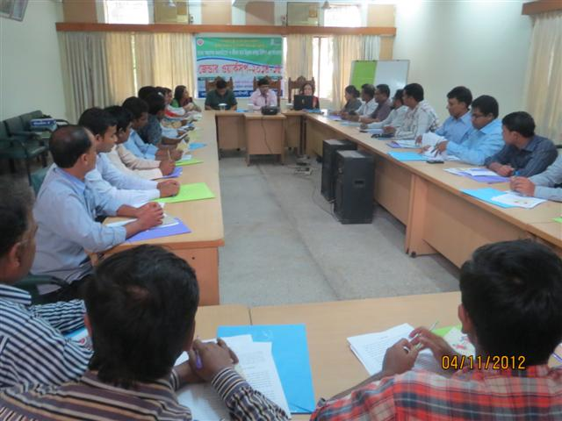
Gender Workshop in HILIP

